**We would like your views!**

[](https://www.google.co.uk/url?sa=i&source=images&cd=&cad=rja&uact=8&ved=2ahUKEwiypuHnw4fbAhWqAcAKHcB0AVAQjRx6BAgBEAU&url=https://www.built-environment-networking.com/event/healthcare-estates-development-forum/lga-logo-for-ccla-site/&psig=AOvVaw1h3Bt5NTHAvsSWQAwqRDLG&ust=1526467258936514)

[](https://www.techuk.org/events/conference/item/3915-adass-care-apps-showcase-2015)We would like your views on some guidance that the Local Government Association (LGA) and the Association of Directors of Adult Social Services (ADASS) are writing.

We want to hear from people with a learning disability, autism or both and family carers.

It is part of the Transforming Care work.

The guidance is to help make sure that people with a learning disability, autism or both who display behaviour that challenges get good quality care and support in the community.

We want the guidance to:

* Help commissioners and providers work together as partners.
* Help commissioners to make sure they are working with providers that have the right values and skills.
* Help commissioners to make sure good providers are available to people in their local area so that people don’t have to live a long way from family and friends.
* Help commissioners to know what good services and good quality care and support providers look like.

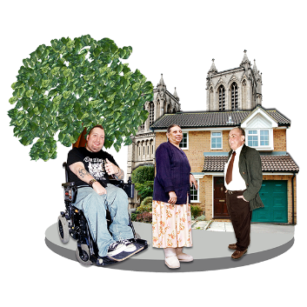

Commissioners are the people who plan and pay for services and support for people in the community.

When we talk about providers we mean the organisations that provide care and support to people to support them with their day to day lives.

[](http://www.photosymbols.com/products/think)We have written the questions below so that people can use to help them give their views if they want to.

But you don’t have to use these questions. You can just tell us what you think from your own experiences.

[](http://www.photosymbols.com/products/support-writing-1)You can email what you think to [jane.alltimes@local.gov.uk](mailto:jane.alltimes@local.gov.uk) until Friday 15 June 2018.

You might want to ask someone to support you to tell us your views.

**What we will do with what you tell us**

[](http://www.photosymbols.com/products/magnifying-glass)

We will look at what people think then write a final version of the guidance.

We might use some things you have said. This is so that we can show what different people have told us. If we do this we won’t use your name.

**About you**



**Are you sending this as an individual or from a group?**

As an individual 🞎

This is joint response from a group 🞎

**What is the name of your group and what does it do?**

**The questions are on the next pages.**

**Thank you very much for giving us your views.**

[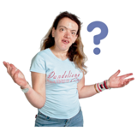](http://www.photosymbols.com/products/confused1)**Questions**

These questions are all about people with a learning disability or autism who display behaviour that challenges.

This is the group of people we are talking about in these questions.



1. **What are the important values that providers should be able show they have?**

For example, this might include things like a commitment to supporting people to become more independent.



1. **What sort of information would you like to know if you were deciding which provider you wanted to support you or your family member?**
2. **What are the key skills that you think providers should make sure their staff have in supporting people with a learning disability or autism who display behaviour that challenges?**

For example, this might include things like making sure staff understand about person-centred approaches or about how to work with people who have no verbal communication.



1. **What do you think providers should be doing to get good feedback about how their service is doing?**
2. **We have thought of 7 things that we think commissioners need to make sure providers are supporting people to do.**

**These are:**

* + Making sure people have choice and control about the care and support they are getting and that people spend their time doing the things they want to do.
  + Making sure people are a part of their communities and have opportunities to develop friendships and meet new people.
  + Making sure people are supported by staff with the right skills and good values.
  + Making sure people are supported to be safe and to manage any risks in a positive way.
  + Making sure people know what money they have for their care and support and have control over how it is being used.
  + Making sure people are supported to stay healthy and well.
  + Making sure people have a choice about where they live and who they live with.



**Do you think these are the right things that providers should be doing? Is there anything missing?**

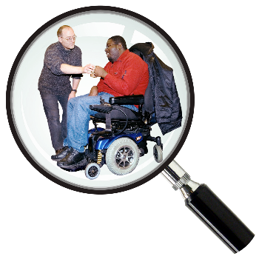

1. **For each of these things, what do you think commissioners could do to check that they are happening?**

For example, to make sure that people have choice and control they might check that every person has a person-centred care and support plan.

Please give us your ideas in the box on the next page.

|  |  |
| --- | --- |
| **Good providers should be:** | **How would we know if these things are happening? Write your ideas in this column.** |
| Making sure people have choice and control about the care and support they are getting and that people spend their time doing the things they want to do. |  |
| Making sure people are a part of their communities and have opportunities to develop friendships and meet new people. |  |
| Making sure people are supported by staff with the right skills and good values. |  |
| Making sure people are supported to be safe and to manage any risks in a positive way. |  |
| Making sure people know what money they have for their care and support and have control over how it is being used. |  |
| Making sure people are supported to stay healthy and well. |  |
| Making sure people have a choice about where they live and who they live with. |  |