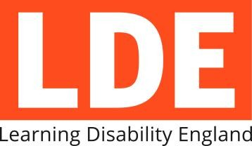

What do individual members get?

A vote.

Membership Form

We are a democratic organisation and all of our members have a say about what we do.

No big decisions will be made unless one third of the vote is from members with learning disabilities

Up-to-date news and information.

You’ll get a regular newsletter sent to your email address.

Members with learning disabilities will get at least two newspapers every year sent to their home.

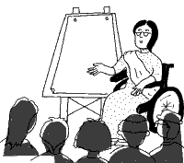
Advice.

Call us and we will give you some independent advice or put you in touch with others that can help.

A chance to get involved.

We train self-advocate and family spokespeople to talk to the media and politicians.

How much does it cost?

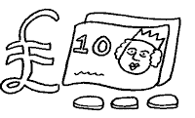 Membership costs £12 a year for individuals.

Learning Disability England | Telephone: 0300 201 0455 | Email: info@ldengland.org.uk
Membership Form

Name

Email Address

Telephone Number

Address

What is the best way to contact you?

Email |  | Letters
Phone |  | Other:

Tell us a little bit about yourself (please tick one):

I have a learning Disability
Someone in my family has a learning disability
A friend of mine has a learning disability
I work for an organisation that supports people with learning disabilities
I am an academic or other independent professional

Pay for membership – please say which way you prefer to pay

Online – by Direct debit: http://www.learningdisabilityengland.org.uk/join-us/

Cheque / postal order- send us a cheque or ask for a postal order at the post office

Please return this form to:

Learning Disability England, Rose House, 4 Preston Street, Faversham, Kent, ME13 8NS

Learning Disability England | Telephone: 0300 201 0455 | Email: info@ldengland.org.uk

