National 3 Day Self Advocacy Convention

The North West Regional Forum are proud to host the UK’s FIRST EVER National Self Advocacy Convention alongside our North West Regional Forum Conference
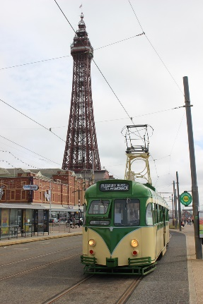

26th - 28th February 2019
At The Grand Hotel, Blackpool

