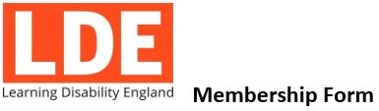
What do individual members get?

An opportunity to:

 | To support and be a part of the change Learning Disability England members are making together
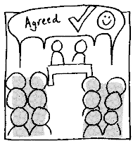 | To join our network of spokespeople, subject leads or partners on issues you care about or have worked a lot on
 | Influence and inform the campaigning or key messages Learning Disability England uses in its work with partners, government or members
Access to:

 | Up to date information, news and resources including a regular e mail newsletter (usually weekly)
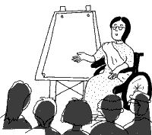 | Events, meetings or conferences we run at a reduced rate or free where we can
 | Each member can also vote on formal decisions or have a say in what LDE does day to day

How much does it cost?
Membership costs £12 a year for individual members

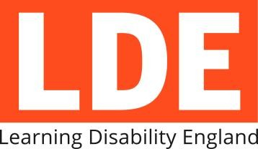 Membership Form

Name

Email Address

Telephone Number

Address

What is the best way to contact you?

Email |  | Letters
Phone |  | Other:

Tell us a little bit about yourself (please tick one):

I have a learning Disability
Someone in my family has a learning disability
A friend of mine has a learning disability
I work for an organisation that supports people with learning disabilities
I am an academic or other independent professional

Pay for membership – please say which way you prefer to pay

Online – by Direct debit: http://www.learningdisabilityengland.org.uk/join-us/

Cheque / postal order- send us a cheque or ask for a postal order at the post office

Please return this form to:

Learning Disability England, Rose House, 4 Preston Street, Faversham, Kent, ME13 8NS

Learning Disability England | Telephone: 0300 201 0455 | Email: info@ldengland.org.uk

