Spokespeople
At learning Disability England, we want to work with all our members to get their voices heard and to tell people what is important to them.
This page tells you about being a spokesperson. You can sign up at the bottom.
What is a spokesperson?
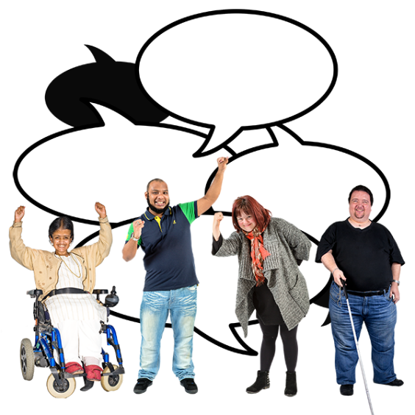
A spokesperson is someone who speaks out about different issues. They do this to help make changes happen.
We want self-advocates, families and staff from organisational members to be spokespeople for LDE.
We know our members have lots of skills, knowledge and experience. We want to make sure you can have your voices heard on topics you are passionate about.

What kind of things will I be asked to do?
There will be different ways to speak up. Some people will want to speak out in lots of places. Some people will want to just speak out in one way.
We need people who can tell us what they think for our news updates. We need people who can go to meetings. We need people who want to talk to journalists.
You can tell us the types of things you would like to do and the things you don’t want to do.

Do people have to know people my name?
Some people are happy to speak in public and have people know their name.
Being anonymous means you can say what you think without giving your name. Sometimes not giving your name can make people feel more confident to speak out.
Let us know if you want to give other people your name or not. We don’t always have to post your name with things you say.

What kinds of things can I talk about?

We want to know what our members know. Please tell us what you know about. This might be things like;
- Funding issues
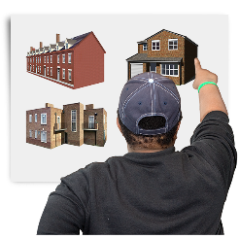
- Housing
- Health care
- Assessment and Treatment Units (ATUs)

How will it work?
When we need a spokesperson, we will look at our list and see who’s interests match the work.
We will contact you to ask if you are interested in taking part. You don’t have to be involved in everything, only the things you want to or when you have time.
Your personal information will only be shared outside of Learning Disability England with your permission.
I might need some support?
We would be happy to support you be a spokesperson. We might support you to plan and write what you think. We might help you to claim expenses for attending meetings.

You can tell us what kind of support you would like when you sign up.

How do I sign up?
If you are interested, click here to sign up. https://www.surveymonkey.co.uk/r/spokespeoplesignup
If you have any questions, please contact:
rachael.hall@LDEngland.org.uk
If you would like some support to sign up, you can ring Rachael on 07490983412

