Self advocacy and working together

Blackpool and beyond……
 | Blog by Sam Clark
 | Last week some of us from Learning Disability England were in a sunny Blackpool.
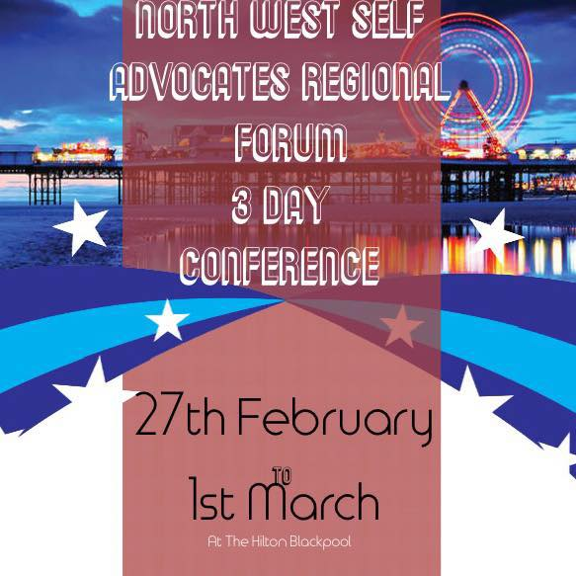 | We were there thanks to the North West Regional Self-advocates forum and NWTDT / Pathways team who agreed to host a national self-advocacy convention with LDE.  This happened at the same time as their very popular annual North West Region self-advocates conference.
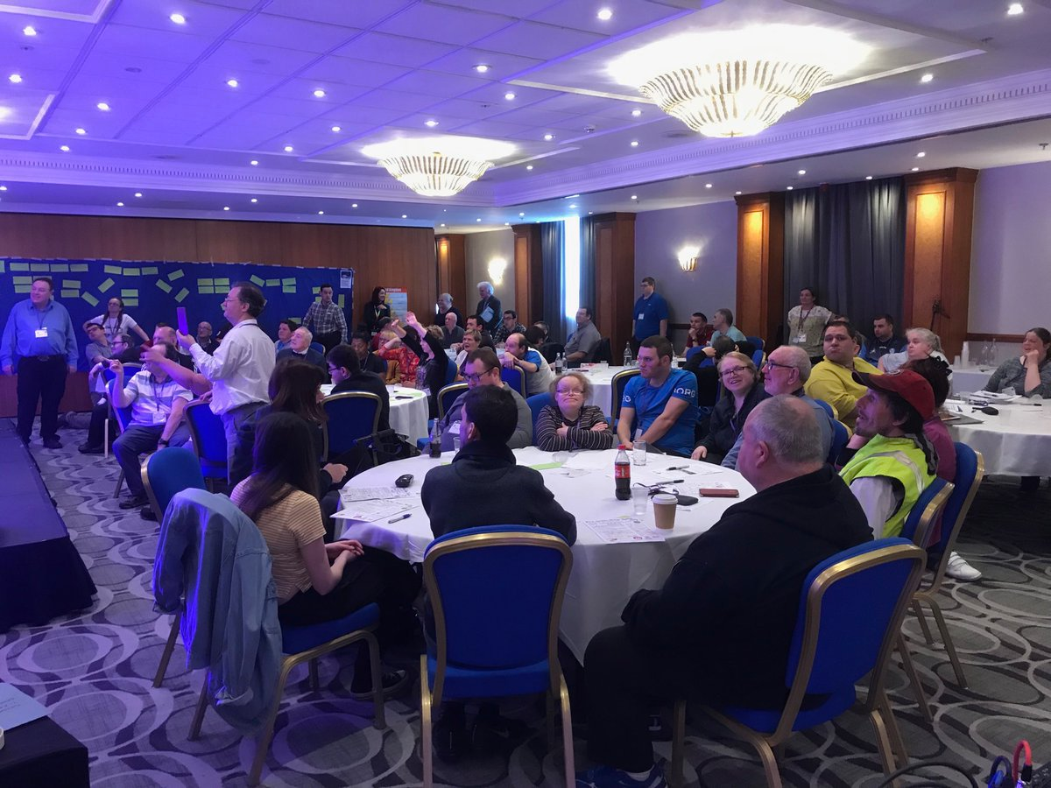 | This meant 45 people with learning disabilities and their supporters from across the country met up.
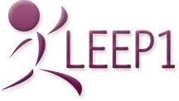  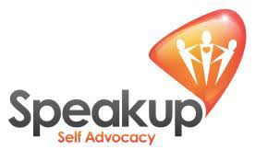  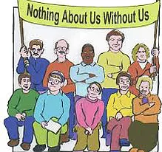 | They were from  10 self-advocacy or human rights organisations from England,  one from Wales.  Sunderland PF  Brighton and Hove Speak out  Rotherham Speak Up  Cumbria PF  Kent Bemix  Leep 1  Change  Inclusion North  My Life, My Choice  Northamptonshire People First
2 self-advocates working for LDE provider member organisations were there too.

We know lots more people wanted to come but could not because of time or money

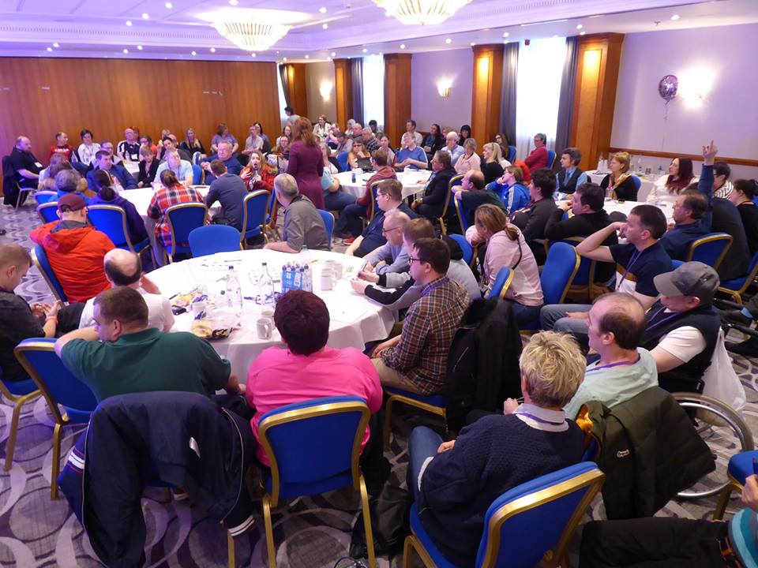 | It was exciting getting to work together and with the 200 delegates from the North West.
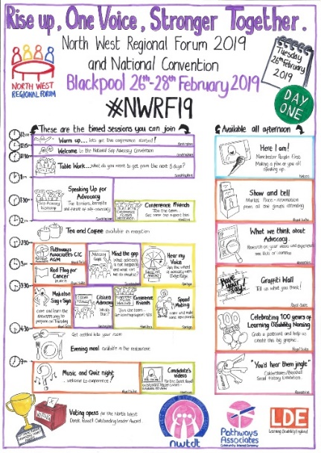 | Before the event we asked self advocates what was important to work on together.  And we made the Programme around that.
 | Most sessions were planned and led by self-advocates.
About us | People tell me the conference was good because it was about people with learning disabilities and what is important to them –  not what I, supporters, friends and organisations think is important.
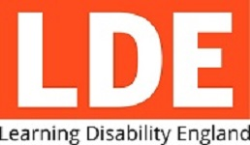 | There are lessons here for Learning Disability England.
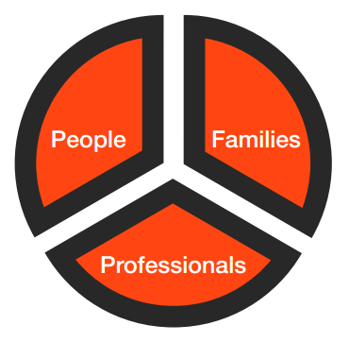 | Learning Disability England exists to bring together people and organisations who share the same values and support our aims to make life better with people with learning disabilities and their families.
Learning Disability England’s aims are to make sure:

- policy makers, services and the wider community know what is important to people with learning disabilities

- services are set up and run based on people’s rights

- we show how co-production and really working together make a difference

- we live these values and act the way we want others to act

Last week we met those aims I think.

There is loads more to do, but it feels like there is hope in the self-advocacy movement.

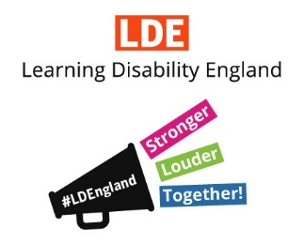 | Learning Disability England has a target that says we will help make self-advocacy stronger  To do that I think we need to connect, support and be an ally to self-advocacy.
 | If we do that well then we can tick all these things
 | - More groups in touch with each other and know about each other’s work
 | - Self advocates standing together and speaking out on what really matters
 | - More self advocates speaking up in public meetings, media, conferences, and blogs
 | - Evidence about the difference self-advocacy makes is easy to find and use
 | - Groups are working together to share resources and make changes
 | - Groups have more information about different ways to get funding
 | - Support providers, families and self advocacy are really working together
 | What do you think? Please do let us know
#SelfAdvocacyWorks | Finally, a plug for #SelfAdvocacyWorks  If you are on Twitter check out the hashtag. Sunderland People First are asking self-advocates to share pictures or examples of their work so they can pull together a snap shot over the next few months of the difference self-advocacy makes.
We are sharing updates and notes or presentations from the convention
Click here

