What are self-advocacy groups doing at this time?
Some of the ways self-advocacy groups across the country are staying productive, connected and helping their members through covid-19

CHANGE
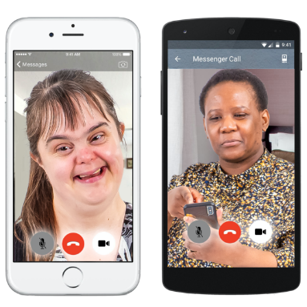
- They are doing a weekly zoom call that gives people with learning disabilities and autism a chance to talk about what’s going on in the world, to share worries, get advice and just chat.

- This zoom call is being held every Tuesday at 3pm.

- They are sharing a zoom link weekly on their Twitter page you can click on if you want to join the call.

Speak out
- They are offering a support helpline for people with learning disabilities during the coronavirus outbreak.

- You can access this helpline for help dealing with a problem, for information or just for a chat.

- The number to call is: 01273 421921 between 9am and 5pm.

- They also have an information hub and chat group that you can access through their Facebook page: https://www.facebook.com/groups/240545953758890/

Dorset People First
- These have produced an activity board which includes different activities to do each day to keep people busy and entertained while staying in-doors.

- They have also produced a coping calendar that has different daily things you can do to support your mental health and wellbeing.

- Please click here to see these calendars:

Dorset People First Coping calendar and Activity Board

- They now have a NEW accessible 'Walk and Talk Club'. People can meet new friends, do exercise in a relaxed environment and explore different areas in their local town.
Speak up
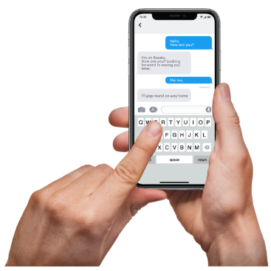
- They have a WhatsApp group and have 25 people chatting on this every day.

- A zoom call at 11am every day - they have up to 20 people joining this call. They check in with each other to make sure they are all ok and chat about the work they can all do.

- A Quiz that they do every week.

- They are currently putting lots of resources and training material on their website to help people. These resources have been coproduced by their self-advocates with learning disabilities, autism or both.

- Their website is; www.speakup.org.uk

Skills for people
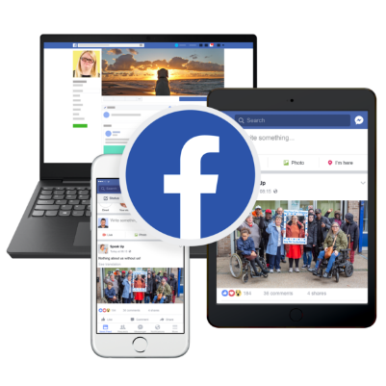
- Their self-advocates have set up a Facebook page called Stay Connected and they are having daily video calls to plan what is being put on this page.
- This includes jokes, important news in easy read and fun competitions to do at home.

People in Action
- Have invited all their members (and whoever else would like to join) to their daily Zoom chats and activities.

- Most of their groups and courses are still running in this way too throughout the week.

- Staff are also posting out Boredom Buster activity packs and calling members on the phone.

People first Merseyside
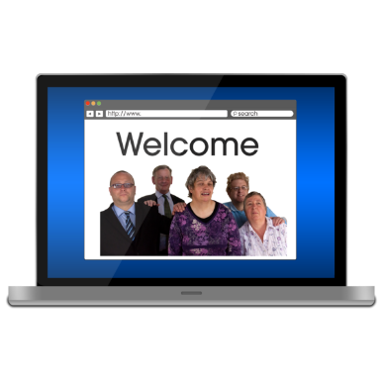
- Are currently working to update their website which will be going live soon.
- Have transferred their group meetings with their members to zoom so that they can still work and socialise.

- Are sharing daily updates on covid-19 on their Facebook page.

- Also keeping members up to date through Facebook with what's happening, and activities people can get involved in.

Cornwall People First
- They are working on a guide on how to structure your days at home. This includes activity ideas and some tips on things you can do to stay busy.

- They are supporting people by phone where they can, especially their members who live on their own or have no close family.

People first forum
- Have a new internet based phoneline which goes to staff mobiles 01202 051014

- Live videos on Facebook which tell their followers how they are coping, gives them up to date information on the coronavirus as well as lots of useful links on exercise, mental health, food deliveries, where to get other support etc.

- Pre-recorded videos every Saturday for entertainment. The first was a quiz and the second was a collation of messages from people with learning disabilities and an art session. More quizzes and entertainment to follow. https://www.facebook.com/PeopleFirstForum/

- They have put a list together of their most vulnerable members who do not have the internet and call them weekly.

- They have also made a ‘my diary of the coronavirus 2020’ so people can record their experiences and are sending out to their 800+ members.
https://issuu.com/peoplefirstforum/docs/diary_template_latest

- They are also sending out to their members a Coronavirus 2020 survival pack which contains lots of content to keep them informed and entertained right now.
https://issuu.com/peoplefirstforum/docs/activity_and_information_booklet_april_2020
- They are setting up Zoom meeting with their members, so people can speak up and keep in touch with each other.

My life my choice
- They have been busy phoning around all the members to see how they’re getting on.
- Some people have had some really good ideas about things to do at home which they have been sharing around to others.
- If people are feeling lonely, they have offered them a Phone Buddy.
- A Phone Buddy will ring you and check in on you for a friendly chat.
- If you are a member and would like to have a Phone Buddy or become a Phone Buddy, call Yazz on 01865 204214 between 10am and 4pm.
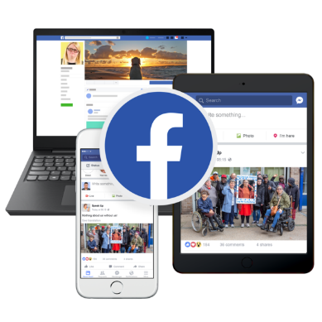
Lewisham speak up
- As people are using social media a lot at the moment, they have put together a video which they have shared on Facebook called ‘Top Tips for staying safe online’.

- To go their Facebook and watch the video follow this link: https://www.facebook.com/LewishamSpeakingUp/videos/177971063188381/

People First Tameside
They have been delivering food parcels to their most vulnerable members and their families.

- They have also been doing mindfulness sessions on Facebook to help people who might be feeling anxious at this time.

Your voice counts
- They are continuing to support the most vulnerable people in the community and are doing over the telephone or video calling as much as possible.

- They are also contacting those who come along to their drop-ins, group activities or self-advocacy groups, and making sure they have the support they need over the coming weeks.

- They are helping people to make plans, including how to get food, medication and how to use technology to stay connected.

Pathways associates/NWDT
- They are sharing daily video updates (Monday to Friday) to make sure that people have accessible, accurate and up to date information about COVID 19.

- Their most recent video answered some questions that self-advocates with a learning disability, autism or both wanted to ask.

- All their previous videos can be seen on the NWTDT YouTube page - YouTube.com/NWTDT

Our voice group
- They have restarted their filmmaking club for adults with learning disabilities which they are running online. These are weekly virtual filmmaking clubs.

- Members are currently planning some lockdown experience videos.

- For more info see their twitter: @ourvoice-filmmakingclub

Sunderland People First
- They now have a Keeping People Connected phone Service which is free and available now for people with learning disability and / or autism who need support.

- This service is helping make sure people understand the coronavirus, helping them to problem solve and stay connected as well as access other services.

- To contact this service call: 07858 226 18
This is just some of the work that we have heard is being done by self-advocates groups. If you know of anymore great work that we can mention – please be in contact with one of our LDE team members at:

anna.balding@ldengland.org.uk
or
gary.bourlet@ldengland.org.uk

