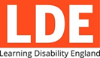
Learning Disability England

Summary of our work and achievements
and
Annual Accounts
April 2020 to March 2021

Easy Read Summary

A summary of our work and achievements in 2020 – 21

 | Learning Disability England brings people and organisations together to create a movement for change.
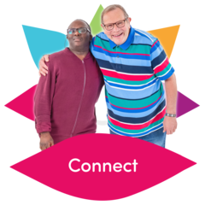 | People with learning disabilities, families, friends and paid supporters come together on an equal basis to work for people with learning disabilities having good lives with equal choices and opportunities as others.
 | Here are some of the things Learning Disability England members and partners worked together on during 2020 / 21.
 | Informing and supporting members
We sent out a weekly online newsletter to all of our members.

More than 2,000 people received the newsletter.

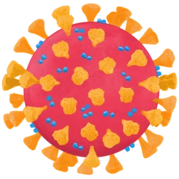 |  | We were given funding to keep people up to date with Coronavirus
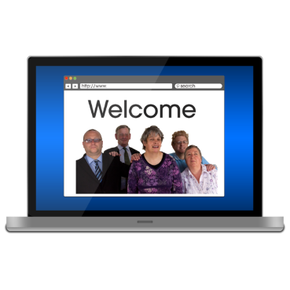 |  | We used the funding to set up an online Covid information hub.
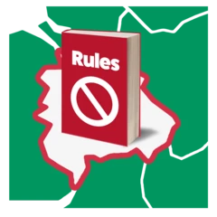 |  |  | The hub informed people of changes to COVID 19 rules.
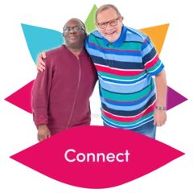 |  |  | It helped to keep people in touch during lockdown.
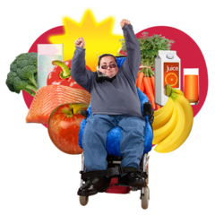 |  |  |  | It gave information on how to keep well and healthy during lockdown and held online events.
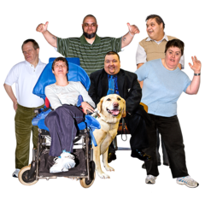 |  |  | The Hub was very popular.  More than 160,000 people visited the website.
 |  |  | Online Presentations (Webinars)
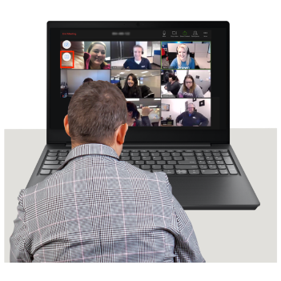 |  |  | We held 9 Webinars hosted by professionals, people with a learning disability, support workers and trainers.
 |  |  | The webinars covered changes to the law due to COVID 19.
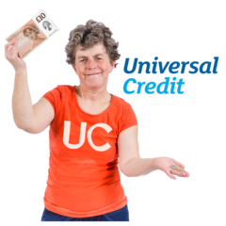 |  |  | We gave advice on knowing your rights and changes to the benefits system.
 |  |  | We discussed the impact of COVID 19 had on people with learning disabilities and their families.
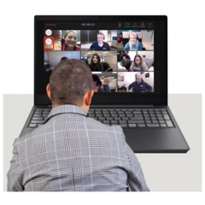 |  |  | Nearly 3000 people attended the live webinars.  Recordings of the webinars were viewed by hundreds of people.
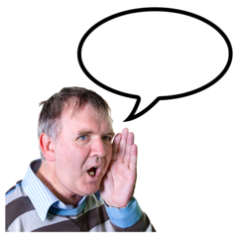 |  |  | Representing members to make changes to policy and attitudes
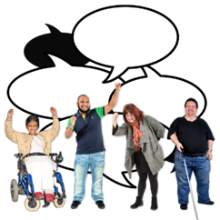 |  |  | We focus on issues our members agree on.  We create a stronger voice when we all speak together.
 |  |  | Last year members were concerned about Coronavirus.
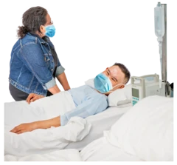 |  |  | We looked at the impact on people with a learning disability around hospital visits.
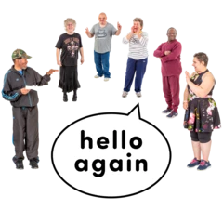 |  |  | We gave advice on meeting people outside when rules were relaxed.
 |  |  | We made easy read information so that people understood the rules as they changed.
We advised people about the Social Care Taskforce and the COVID 19 Winter Plan.

The Social Care Taskforce was set up to make sure that those who need care stay safe.

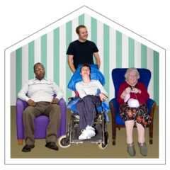 |  |  | We looked into the impact on people living in supported living, residential care or receiving community support.
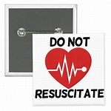 |  |  | Do Not Resuscitate Notices
During Coronavirus some disabled people and older people were told that doctors would not try to restart their heart if they became very unwell. This is a Do Not Resuscitate notice (DNAR)

Our members were upset about policies regarding DNAR for people with learning disabilities.

 |  |  | We did research and shared a report to be presented to policy leads and national government.
 |  |  | Learning Disability England shared their members’ views with a Government committee on Do Not Resuscitate Notices.
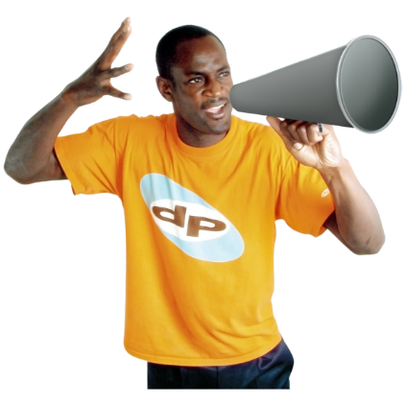 |  |  | We supported members to campaign and share their views.
We worked with Turning Point on a Toolkit to help people understand their rights and how to challenge Do Not Resuscitate Notices.

Turning Point is an organisation that offers health and wellbeing services to people with a learning disability and complex needs.
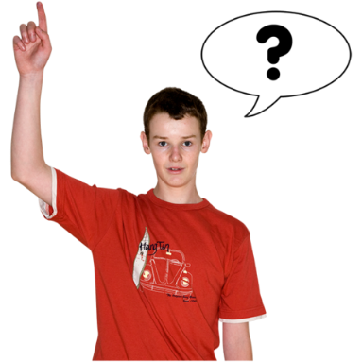 |  |  | Consultations
 |  |  | We collected member’s views and gave evidence to the Government on:
 |  |  | - Life after Covid 19, shared with the House of Lords
 |  |  | - National Disability Strategy
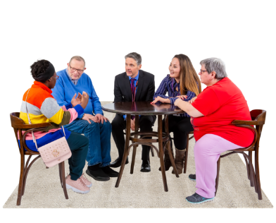 |  |  | - Social Care Taskforce Learning Disability and Autism Advisory Group.
L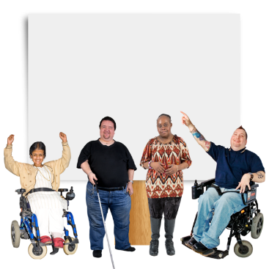 |  |  | We fed back on other issues including:  - The Care Quality Commission Strategy  - The future of social care  - Mandatory vaccinations for staff working in residential care.
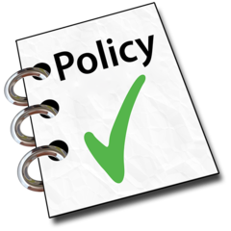 |  |  | More than 500 organisations, groups and members were involved in feeding back views or shaping policy.
 |  |  | We helped Government Departments on improving health services and policies.
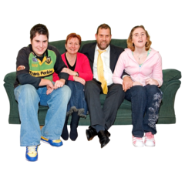 |  |  | We helped people with learning disabilities and their families work together to make changes to policy.
 |  |  | We supported members to train as Pass it On Mental Health Trainers
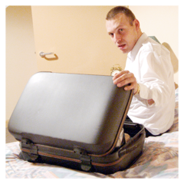 |  |  | We made recommendations for changes to short breaks and day services.
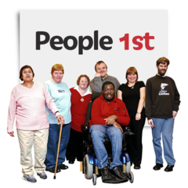 |  |  | We received a grant from RTR Trust to build a national self-advocacy movement.  The Rix-Thompson-Rothenburg (RTR) Trust supports projects that help people with learning disabilities.
 |  |  | We created a Family Voices report on people’s shared experiences during the COVID 19 Pandemic.
 |  |  | We worked together with other organisations to make a difference
 |  |  | We worked with York University on the Big Housing Conversation 2020.
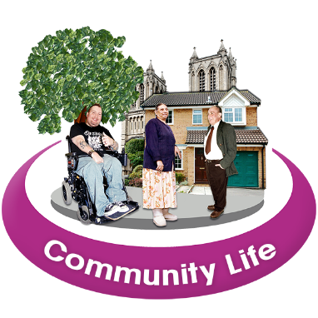 |  |  | We used funding from Department of Health and Social Care to support user led and community services to keep going during the pandemic.
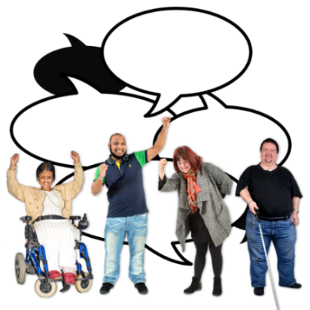 |  |  | We campaigned about things our members cared about.
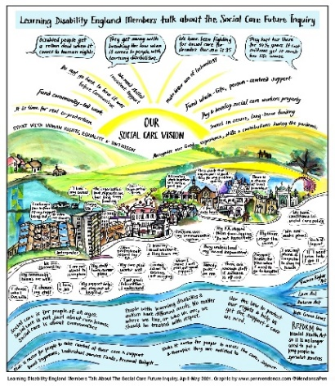 |  |  | We are part of the Social Care Future movement.
 |  |  | We supported the campaign against the cuts to Support Packages
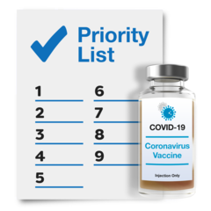 |  |  | We campaigned for priority access to the COVID 19 vaccine for people with learning disabilities.
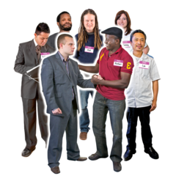 |  |  | We campaigned for reasonable sleep-in payments for support staff.  A sleep in payment is given to care staff who stay overnight and give assistance to people.
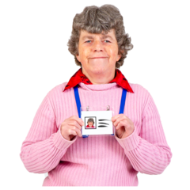 |  |  | We took part in the Walk it like you Talk it employment campaign.
 |  |  | We were part of the Right2Home Campaign for people to live in their own homes instead of long stay hospitals.
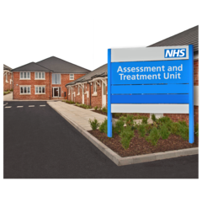 |  |  | We promoted the rights of people in long stay hospitals in the Human Too Campaign.
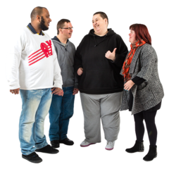 |  |  | We promoted members’ values and changes they wanted
 |  |  | We worked with the JMS Trust to promote supported living.
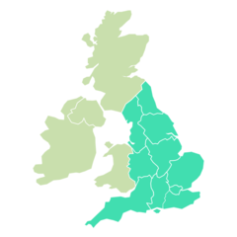 |  |  | We hold the Self Advocacy map developed by Sunderland People First and Sheffield University on our website.
 |  |  | We supported the Accessible Information campaign.
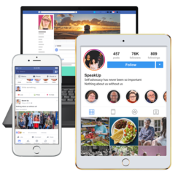 |  |  | We supported the Digital Lifeline Project to keep people connected during lockdown.
 |  |  | We took part in research by Universities in Manchester and Warwick on the impact the Coronavirus pandemic had on people with learning disabilities.
 |  |  | Our partnerships
 |  |  | We are a partner in the Valuing People and the Health and Wellbeing Alliance to improve services for all communities.
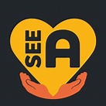 |  |  | We partnered with SeeAbility on the Creating Connections Project.
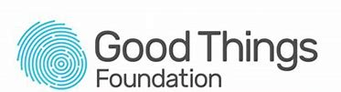 |  |  | We worked with the Good Things Foundation on promoting Digital Inclusion.
 |  |  | We promoted annual health checks working alongside NDTi, Skills for Care and VODG.
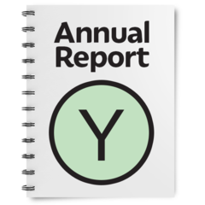 |  |  | The annual accounts 2020-2021
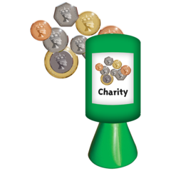 |  |  | Learning Disability England is a registered charity.  This means we are registered with the Charity Commission.
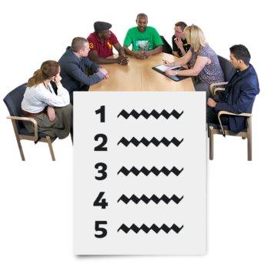 |  |  | The Board of Trustees makes sure we work to the Charity law rules.  You can see who is on the Board of Trustees here
The Trustees work closely with the Representative Body (Rep Body).

The Rep Body is chosen by members.

The Rep Body decides the priorities for Learning Disability England with members and Trustees.
In February 2020 there was a Representative Body election for 6 new reps.

Members voted in June.

1 person was re-elected and 5 new reps joined the Rep Body in July.

You can see who is on the Rep Body here

In March 2021 we had 7 staff.

Some of these are part time.

This means staff worked the same number of hours as 6.5 full time staff.

You can see who the staff are here
All the staff worked from home because of COVID 19.

We had to close our office in Faversham during the COVID 19 lockdown.

We will soon be opening a new office.
 |  |  | The money coming in and the money spent
The total money coming in was £416, 339.

Most of this money was from membership fees, grants and work Learning Disability England did.

 |  |  | The total money we spent was £358, 468.
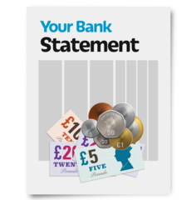 |  |  | The money we had left in savings in March 2021 was £116, 667.  This is called reserves.  The Trustees keep some money in savings (reserves) for emergencies. They have a policy on this and how they decide what they keep savings for.
The money coming in and the money we spent was more than the year before.

This graph shows the difference.

The orange lines are 2020 to 2021.

The blue lines are 2019 to 2020.
 |  |  | The annual accounts were prepared and checked by P&W Social Accountants in Birmingham.
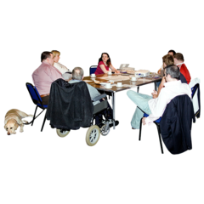 |  |  | The annual accounts were checked and approved by the Board of Trustees.  You can read other reports about Learning Disability England’s work on our website here

