Planning for the next 10 years of the NHS
Meetings about how people with a learning disability or autism will be included in the plan
 |  | What this is about
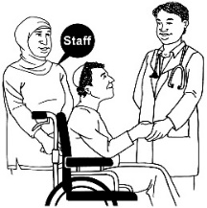 |  | People with a learning disability and autistic people are included as one of the important priorities for the NHS in the next 10 years.
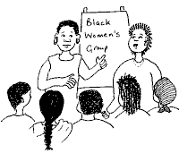 |  | NHS England is working with Learning Disability England to hold 7 meetings to talk about what needs to be in the plan.
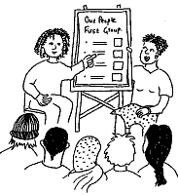 |  | The ideas for the plan will be based on the work so far and what people have said is important or needs to happen next.  The meetings will talk about the work that has happened so far on making health services better, Transforming Care, Learning from deaths reviews (LeDeR) and other important work.  We will talk about what has worked and what hasn’t, as well as the evidence from research or numbers.
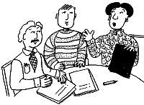 |  | We will use these to focus on what actions we think should be in the plan to make the difference we need across all NHS services.
We will especially look at what is important for
- Autistic people
- Children and young people
- People with a learning disability

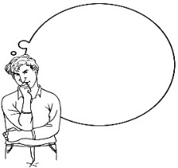 |  | Who is invited to these meetings
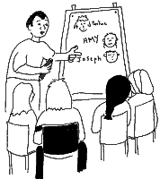 |  | These meetings are for people with lived experience or relevant jobs. We especially hope that these people will come and help work out the important things to be in the plan –
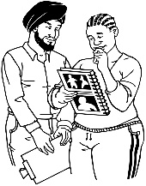  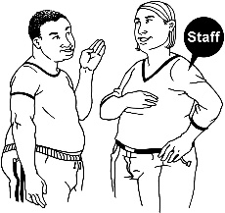  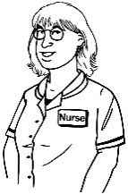  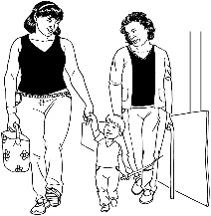 |  | - Autistic people  - People with a learning disability  - Family members of autistic people or people with a learning disability  - Staff who work in specialist services for people with a learning disability or autistic people in health, social care or community organisations  - Staff who work in services that include autistic people or people with a learning disability  - Commissioners who plan and buy services for autistic people or people with a learning disability
 |  | When the meetings are
Date | Region |  | Town | Time | Register
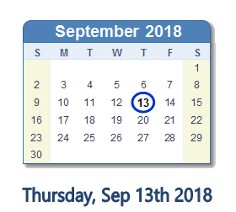 | South |  | Taunton | 10.30 – 3pm | EVENTBRIGHT LINK
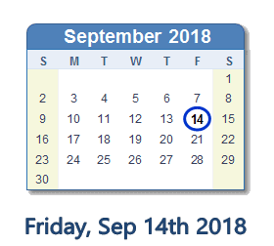 | South |  | Reading | 10.30 – 3pm | EVENTBRIGHT LINK
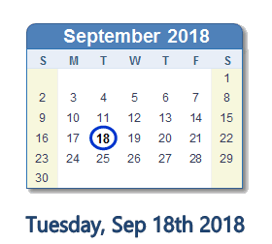 | London |  | London | 10.30 – 3pm | EVENTBRIGHT LINK
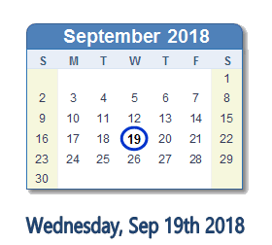 | Midlands and East |  | Newmarket | 10.30 – 3pm | EVENTBRIGHT LINK
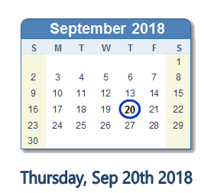 | Midlands and East |  | Birmingham | 10.30 – 3pm | EVENTBRIGHT LINK
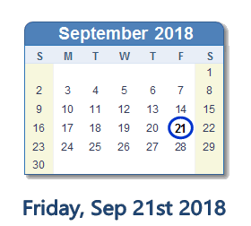 | North |  | Manchester | 10.30 – 3pm | EVENTBRIGHT LINK
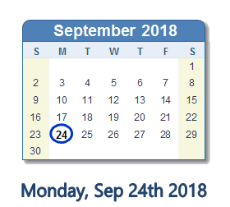 | North |  | York | 10.30 – 3pm | EVENTBRIGHT LINK
 |  | How to book your place
EVENTBRIGHT  LINK |  | You can book by clicking the EVENTBRITE LINK above
 |  | Or by e-mailing us at info@LDEngland.org.uk
 |  | Or by phoning us 0300 201 0455
 |  | When you book your place, we will tell you more about the venue and the plan for the meeting.
 |  | This event is free, but you need to book a place to come.
 |  | There are only 50 places at each meeting so book early if you want to come. Please do not book extra places unless you are sure you or people you know can use them as we want to make sure as many people as possible get a chance to come and have their say.

