Blackpool Self Advocacy Convention February 2019
This Conference is the annual event run in the North West of England by Pathways Associates and the North West Training and Development Team. This year for the first time other groups were invited to attend.
In the North West the Regional Forum is very active. There are really strong groups in Manchester and Liverpool, and several other large well established groups – though some are in funding danger, like Bury. They have a system of calling the great and the good from health and social care to the Conference to hear what members have to say, and to answer to them. It would be good to develop this elsewhere.
I attended with 2 hats. As supporter to My Life My Choice representatives, Ben, Gina and Paul; and to promote the Self Advocacy Toolkit with Alan Armstrong (BAROD). Our little group of outsiders was augmented by Ian Davies and Craig Hart from Northamptonshire People First, both veterans of the National Forum.
Other groups present from outside the North West were:
Sunderland PF
Brighton and Hove
Rotherham Speak Up
Cumbria PF
Kent Bemix
Leep 1 (Leeds People First)
Change People also came one day
Inclusion North self advocate reps
The majority of delegates were from the north west, but they made us outsiders feel very welcome. The whole atmosphere was brilliant and seeing so many self-advocates gathered in one place was amazing, unforgettable. The Gala dinner, Karaoke and Disco was a highlight, with loads of people dancing and having a really great time.
The Conference was structured with big events in the large hall, and smaller workshops in other rooms. People had to sign up for the other workshops, though in practice no one checked and you could go to any that took your fancy.
For me, the best events were those where people shared experiences and ideas.
The funding workshop was a highlight. The groups who were there talked about how much money they have, and the different ways they get money. Some get a bit from their Local Authorities, some get none. Some sell services like Easy Read, inspections and training. Some get grants. Some get CCGs or other bodies to pay them to do things like cancer awareness. There was brilliant learning from this workshop, though regrettably no one recorded it.
Our Toolkit workshop also became a sharing event, where people talked about the different projects they have done. People were really interested in MLMC’s Travel Buddies. There was a lot of discussion about how much self-advocacy relies on the work of volunteers, and whether this is right. Or if people should be paid.
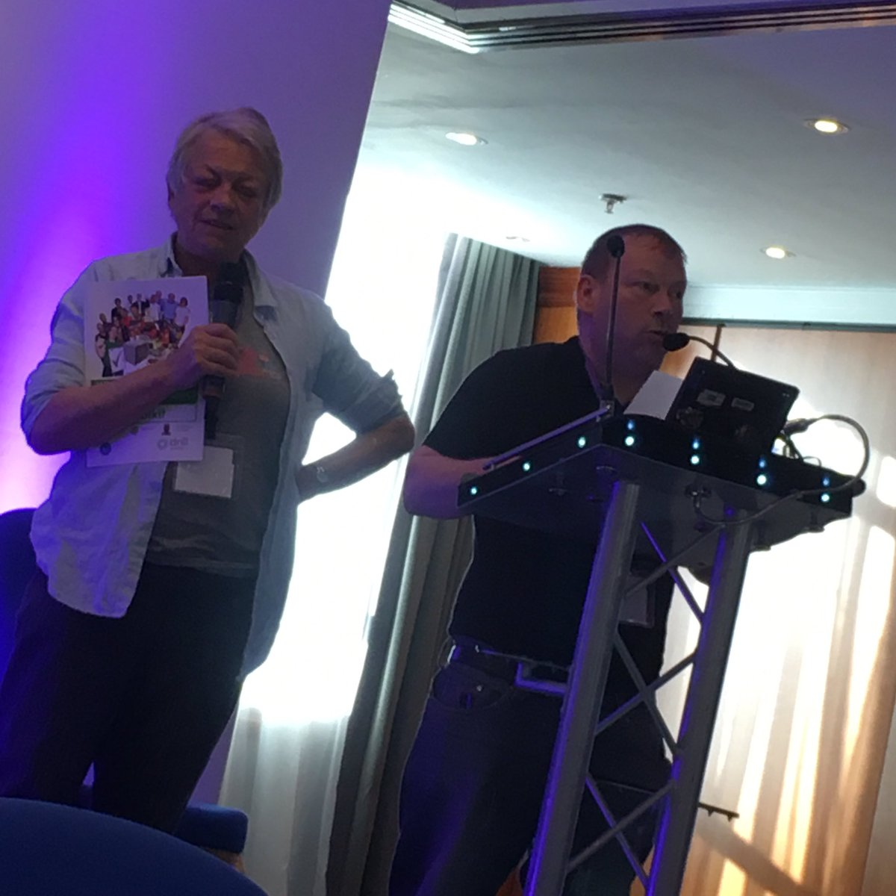
Sunderland PF and Cumbria are doing a joint cancer awareness project and are sharing resources to make this happen.
Alan (BAROD) told the North West groups about Pegasus scheme in mid and West Wales run by Dyfed Powys police. People can register to have their names, address and medication needs held by police, and can call a special number if they need help or see a crime. Police will prioritise them.
Paul told them about Gig Buddies, Travel Buddies and the Night Club at MLMC.
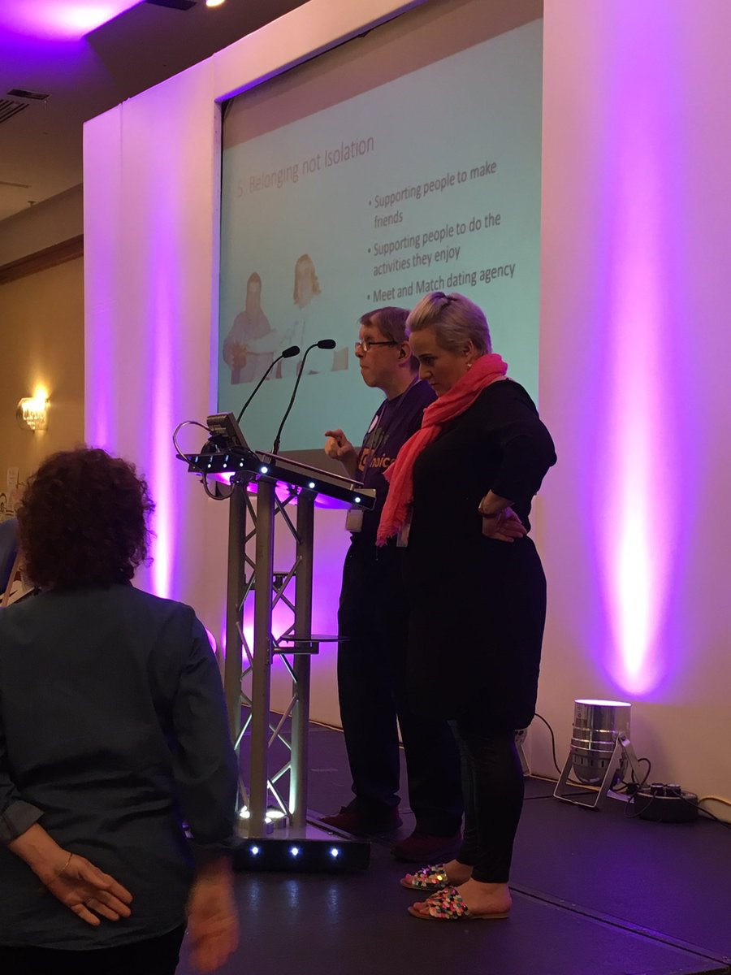
The Conference ended with the Not the North West groups meeting to share ideas about what next for them. Sam Clark from LDE led this session. People had really enjoyed coming together, and said how much they’d liked meeting new people, and learning from others. They thought that an event next year, perhaps in Birmingham area, would be good. Alan and others thought some people from Wales should be there, and possibly Scotland and Northern Ireland also.
We thought it would be important if we are to have a loud voice on important topics, like amendments to the Mental Capacity Act, to have lots of people joining together to make that voice loud.
We ended by thanking Lynn James – Jenkinson, Pathways and NWDT for their hard work in making the Conference such a success. Personally, I’d like to record that the Hotel was excellent, staff very helpful, food plentiful and good quality, and plenty of space. And to thank the starlings over Blackpool pier for their sunset display.

