Health Through Rights - Self Advocacy as a Social Movement
Learning Disability England is working with 5 self-advocacy or human rights organisations as 1 of 7 social movements for better health that Nesta is supporting over the next year.
A social movement is when lots of people come together to try and make change happen.
We want our social movement to make self-advocacy stronger.
We want to campaign on issues around health.
We want to help people live longer, healthier lives.

Together we want to learn how to use social movement ideas to start to;
- Change the image of people with learning disabilities,
- Make more people aware of inequalities,
- Get more members of the public and professionals to stand up to discrimination and inequality.

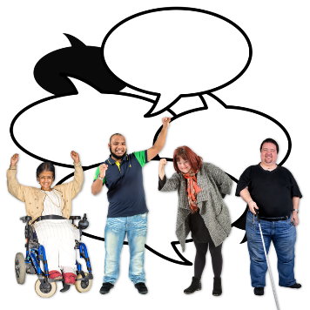
Working with self-advocates and self-advocacy groups are an important part of this work.
We hope people want to connect, to share and learn with us.

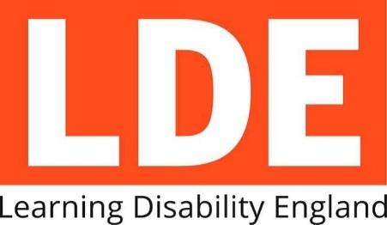
We are just starting this work and making our plans.
We will share what we are doing and updates through LDE’s website.

The 5 organisations leading on this are
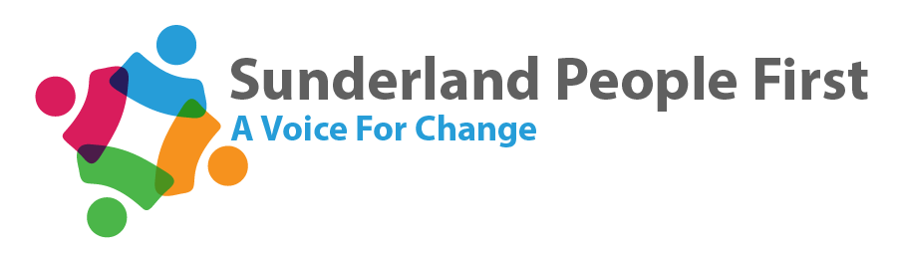
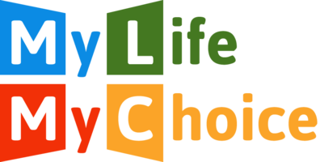
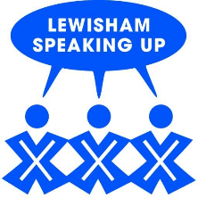

You can click on the groups logo to learn more about them.

Some of the leaders of this work have told us why it is important.

Jodie from Sunderland People First said,
“After losing our National Forum voice for people with a learning disability, Sunderland People First are excited to be part of a new movement to give people with a Learning Disability a louder voice together.”

Steve from bemix said, we want to work on a social movement
“so people have a stronger voice and get better health.
We need to campaign on the same things and support each other in these hard times when funding has been cut.
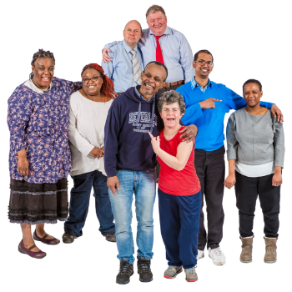
One area might think they are on their own with a problem, but there may be other people also working on sorting it out.
It is about joining up to get stronger across the country.”

Samantha Clark from LDE said
“Working with Nesta and other social movements is really exciting – it gives us all the chance to learn a lot from each other as well as from people with skills and knowledge we don’t have.
I think the people with learning disabilities involved will also teach other people and organisations a lot about inclusion and working in real partnership.
It is brilliant that other LDE members can learn from the self-advocate members and that they are leading this work on social movements.”

To find out more about the joint work you can contact Rachael Hall on Rachael.Hall@LDEngland.org.uk

