No more reports – time for action together, sharing power and expertise

“This is people’s lives …. being wasted whilst we wait for change”

Jordan Smith, LDE self-advocate representative

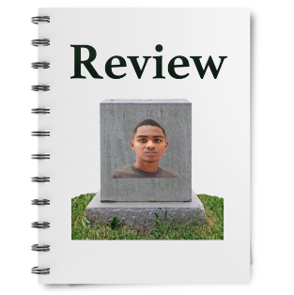
People with Learning Disabilities are still not treated as equal citizens.
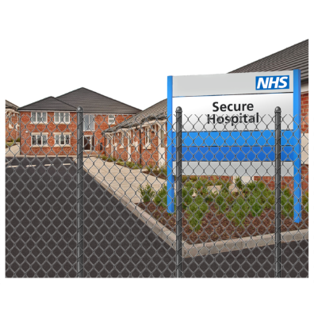
Another report tells us that people with Learning Disabilities are still dying younger.

We know that some children and young people remain locked in hospitals because there is nowhere else for them to go.

The Panorama programme on Wednesday 22nd May left us feeling angry.

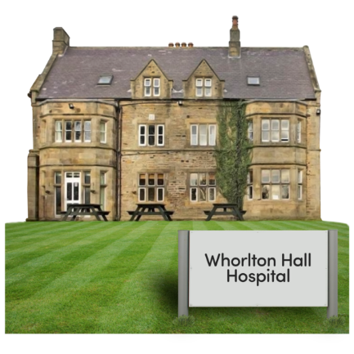
The programme showed people with learning disabilities and/or autism being abused by staff at Whorlton Hall Hospital.
This should not still be happening.

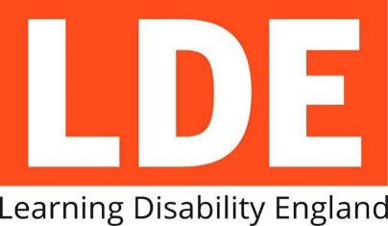
At Learning Disability England, we know people with learning disabilities and autistic people are equal citizens, with the same rights as anyone else.
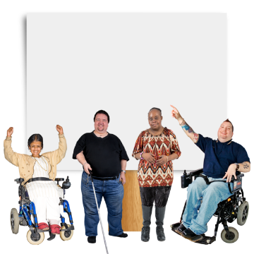
Rights
We want children, young people and adults with Learning Disabilities and Autism to be treated as human beings, with human rights.

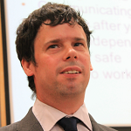
“No more reviews or reports – act now”
Scott Watkin, LDE organisations representative

In 2011 Panorama made a programme on the abuse at Winterbourne View.

Since then, there has been national and local reviews, reports and improvement plans.

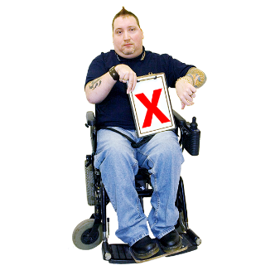
8 years later, too many people still do not have support to live a good life.

A life that includes the things that matter to them like work, friends, family and a safe home.

At Learning Disability England, we support the UN Convention on the Rights of Persons with Disabilities.

The UN Convention on the Rights of Persons with Disabilities is an agreement which lots of countries have signed up to.
It says what countries must do, to make sure that disabled people have the same rights as everybody else.

Article 19 is about living independently and being included in the community.
It says there should be
“equal right of all persons with disabilities to live in the community, with choices equal to others”
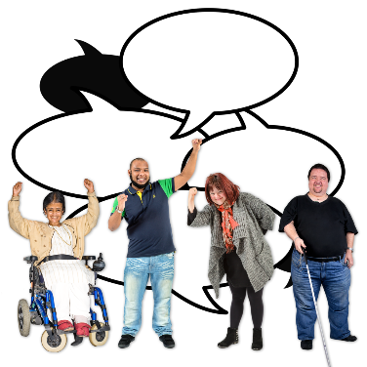
We want action to achieve equal rights and choices for everyone.
We want this to be based on the on the good work that already exists.

Many of our members can share examples of that working.

“People need to know people with learning disabilities matter – there needs to be consequences for people who abuse them or failing services”
Wendy Burt, LDE family member representative
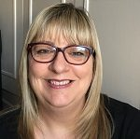
We keep hearing of failings or abuse.
But we are not sure there is justice for the people affected or change in organisations involved.
Our members tell us that support needs to be there earlier.
They tell us about the damage caused by help that does not arrive until someone is in crisis.
We know that support staff need to be supported as well.
When they are unsure or unsupported it is harder for them to do the right thing all the time.
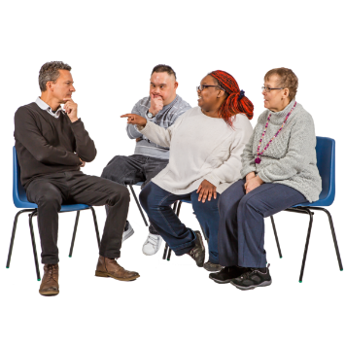

We want services and support that respect and listen to people and their families.
So that they help where and when they are needed.

What we are doing
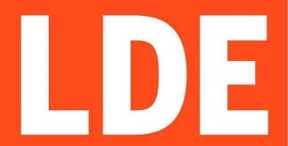
Learning Disability England exists to work for change.
We bring together people and organisations to make a difference together.
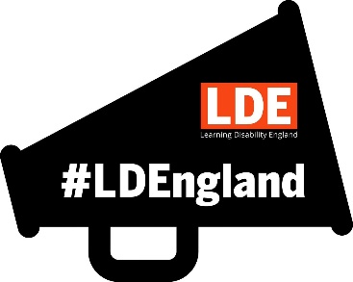
We will keep taking action based on what our members tell us is important.

This includes
- Speaking up on what self-advocate, family and organisation members tell us is important

We will share and support the campaigns and work of our members and allies to support us all being a louder voice together.

For example Rightful Lives, or Am I your problem? or The Being Heard in Government Group.
We will ask questions of people and organisations that make policy or service decisions

We will hold them to account for what they do, for example when things go wrong.

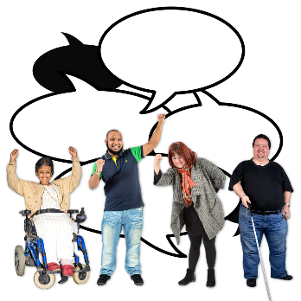
- Working with our members to help them lead change together
We will work with our members to solve problems or support new ways of working
For example, supporting self advocacy groups in building a social movement.
We will challenge and support our organisational members to base their work on rights and what disabled people say is important.

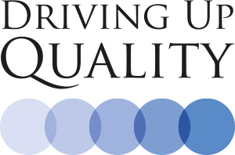
For example, we will look at action on the Driving Up Quality code again.

3. Working with policy makers to help and challenge them. We are connecting them to our members’ skills and expertise

We will keep a focus on what works.
Our priorities being set by people with learning disabilities
For example, how policy is implemented.

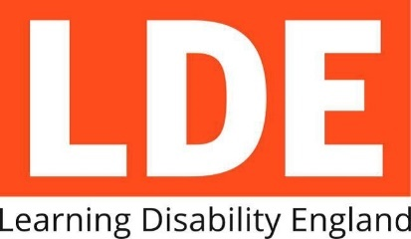

About us
You can find out about Learning Disability England’s Representative Body members and what we do here.
You can click here to get in touch
If you want to join us or if talk about how we can work together for change

