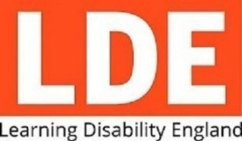
Covid Response Grant Pot Criteria

Learning disability England are awarding small grants of up to £5,000 with money from the Department of Health and Social Care.

The money must be used to help organisations who support people with autism, people with learning disabilities and people with profound and multiple learning disabilities, and their families and carers.

It needs to help these organisations respond to covid-19.

It should be used by the organisations to help its members stay strong and keep going during the coronavirus outbreak.

The money is for:

- User lead organisations
- Registered charity
- Not for profit organisations
- Organisations based in England

The money is not for:

- Individual people
- Political parties
- Religious activities
- Statutory activities - must be done already by law.

We will fund both adults and child organisations.

We will also fund family carer organisations.
We will prioritise self-advocacy groups.

We will prioritise small and medium organisations.

These are organisations with a turnover of less than 1 million.

Less than £10,000 | micro
£10,000 to £100,000 | small
£100,000 to £1 million | medium

Source: Then National Council for Voluntary Organisations 2020

How much will we fund?

There is no minimum amount that can apply for.

The maximum amount we can give to one applicant is £5,000
There is not a specific time frame that the money must be spent by.

We will ask each applicant to say exactly how the money will be spent.
We will ask for feedback as to how they spent it.
 | What will we fund?
We will fund…

- New projects
- Activities
- On off events
- Adapted services
- Short fall in funding due to covid-19? y
- Equipment – with a cost of £4800 or less
- Training to use equipment – by existing staff
- Information/ Promotional material

We will not fund…

- Core costs
- Utility bills
- Debts and loans
- Building or refurbishment projects

What you need to provide

Registered charity number or community interest company number

If your group is not registered as an official organisation, then you can apply under an umbrella organisation.

If you are going to apply in this way then we must check with a senior member of that organisation who can vouch for the group.

They must be unrelated to the group but know of their work. We suggest you contact us to discuss this before applying.
You must name two contacts as references.

You must have double signatory on bank account.
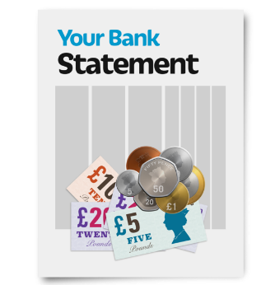 | You must provide a bank statement from the last 3 months from your organisations official bank account.  See the application guidance notes for more information or get in touch with Yazz Davies  yazz.davies@ldengland.org.uk  or call 0300 1110444

