What are self-advocacy groups doing at this time?
Some of the ways self-advocacy groups across the country are staying productive, connected and helping their members through covid-19

If your group is on this list and your activities have now changed, please let us know.

CHANGE
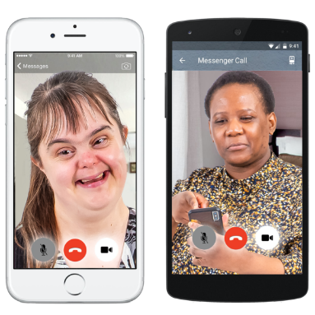
- They are doing a weekly zoom call that gives people with learning disabilities and autism a chance to talk about what’s going on in the world, to share worries, get advice and just chat.

- This zoom call is being held every Wednesday at 12.30pm.

- They are sharing a zoom link weekly on their Twitter page you can click on if you want to join the call.

Speak out
- They are offering a support helpline for people with learning disabilities during the coronavirus outbreak.

- You can access this helpline for help dealing with a problem, for information or just for a chat.

- The number to call is: 01273 421921 between 9am and 5pm.

- They also have an information hub and chat group that you can access through their Facebook page: https://www.facebook.com/groups/240545953758890/

People First Dorset
- They have produced an activity board which includes different activities to do each day to keep people busy and entertained while staying in-doors.

- They have also produced a coping calendar that has different daily things you can do to support your mental health and wellbeing.

- Please click here to see these calendars:

Dorset People First Coping calendar and Activity Board

- They now have a NEW accessible 'Walk and Talk Club'. People can meet new friends, do exercise in a relaxed environment and explore different areas in their local town.

- They now do weekly zoom calls so people can catch up with friends.
If you are interested in this ring 01305 257600 or email laurad@peoplefirstdorset.org.uk

- On the 16th June they are holding a zoom coffee morning for people to catch up. For more info or to book your space contact zoe@peoplefirstdorset.org.uk

- Fortnightly newsletters to people with learning disabilities across Dorset and Somerset includes up to date information to find out latest news in an accessible format, more activities, opportunities for friendship and ideas to look after ourselves

Speak up
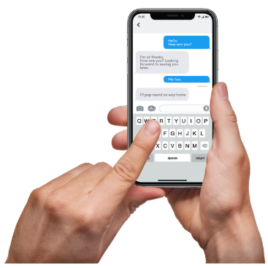
- They have a WhatsApp group and have 25 people chatting on this every day.

- A zoom call at 11am every day - they have up to 20 people joining this call. They check in with each other to make sure they are all ok and chat about the work they can all do.

- A Quiz that they do every week.

- They are currently putting lots of resources and training material on their website to help people. These resources have been coproduced by their self-advocates with learning disabilities, autism or both.

- Their website is; www.speakup.org.uk

Skills for people
- Their self-advocates have set up a Facebook page called Stay Connected and they are having daily video calls to plan what is being put on this page.
- This includes jokes, important news in easy read and fun competitions to do at home.

People in Action
- Have invited all their members (and whoever else would like to join) to their daily Zoom chats and activities:
11am - chats and games
2pm - Stay Active - inclusive exercise session
4pm - Member chat
Contact them for the passwords to join!

- Staff are also posting out Boredom Buster activity packs and calling members on the phone.

People first Merseyside
- Have a new updated website.

- Have transferred their group meetings with their members to zoom so that they can still work and socialise.

- Recently had an online disco for all their members and staff.

- Are sharing daily updates on covid-19 on their Facebook page.

- Also keeping members up to date through Facebook with what's happening, and activities people can get involved in.

Cornwall People First
- They are working on a guide on how to structure your days at home. This includes activity ideas and some tips on things you can do to stay busy.

- They are supporting people by phone where they can, especially their members who live on their own or have no close family.

People first forum
- Have a new internet based phoneline which goes to staff mobiles 01202 051014

- Live videos on Facebook which tell their followers how they are coping, gives them up to date information on the coronavirus as well as lots of useful links on exercise, mental health, food deliveries, where to get other support etc.

- Pre-recorded videos every Saturday for entertainment. The first was a quiz and the second was a collation of messages from people with learning disabilities and an art session. More quizzes and entertainment to follow. https://www.facebook.com/PeopleFirstForum/

- They have put a list together of their most vulnerable members who do not have the internet and call them weekly.

- They have also made a ‘my diary of the coronavirus 2020’ so people can record their experiences and are sending out to their 800+ members.
https://issuu.com/peoplefirstforum/docs/diary_template_latest

- They are also sending out to their members a Coronavirus 2020 survival pack which contains lots of content to keep them informed and entertained right now.
https://issuu.com/peoplefirstforum/docs/activity_and_information_booklet_april_2020
- They are setting up Zoom meeting with their members, so people can speak up and keep in touch with each other.

My life my choice
- They have been busy phoning around all the members to see how they’re getting on.

- They have lots of online events and activities going on such as arts and crafts and cooking videos.

Follow this link to see all their June activities: https://www.facebook.com/photo?fbid=2563537667241015&set=pcb.2555001474761301

- If people are feeling lonely, they have offered them a Phone Buddy. A Phone Buddy will ring you and check in on you for a friendly chat.

- If you are a member and would like to have a Phone Buddy or become a Phone Buddy, call Yazz on 01865 204214 between 10am and 4pm.

Lewisham speak up
- As people are using social media a lot at the moment, they have put together a video which they have shared on Facebook called ‘Top Tips for staying safe online’.

- To go their Facebook and watch the video follow this link: https://www.facebook.com/LewishamSpeakingUp/videos/177971063188381/

- They are also doing regular easy read documents about the coronavirus updates. They have just made one on transport updates for London. Follow the link below to see this on their twitter: https://twitter.com/LewSpeakUp

- They have been doing Facebook live videos talking about different issues. Go to their Facebook page to see these.

People First Tameside
- They have been delivering food parcels to their most vulnerable members and their families.

- They have a whole online activity programme full of things going on this month including; a drawing group and karaoke night.
To see the programme, follow this link:
https://drive.google.com/file/d/1AW-fyq3j3E8EP1s_MOgOmE8Bw4Ra3kCA/view?fbclid=IwAR2Z0PZ3rS1w68cdUWgVS5MijfAhvrsvbIaekR8Vackv_6EXFKLFNNktOto

Your voice counts
- They are continuing to support the most vulnerable people in the community and are doing over the telephone or video calling as much as possible.

- They are also contacting those who come along to their drop-ins, group activities or self-advocacy groups, and making sure they have the support they need over the coming weeks.

- They are helping people to make plans, including how to get food, medication and how to use technology to stay connected.

Pathways associates/NWDT
- They are sharing daily video updates (Monday to Friday) to make sure that people have accessible, accurate and up to date information about COVID 19.

- Their most recent video talked about wearing face coverings.

- They have a big range of online activities going on this month such as singalongs, yoga, cinema club and bingo.

- To see an activity programme follow this link: https://www.facebook.com/photo?fbid=10157535436043262&set=pcb.10157535439518262

- All their previous videos can be seen on the NWTDT YouTube page - YouTube.com/NWTDT

Our voice group
- They have restarted their filmmaking club for adults with learning disabilities which they are running online. These are weekly virtual filmmaking clubs.

- Members are currently planning some lockdown experience videos.

- For more info see their twitter: @ourvoice-filmmakingclub

- They are frequently updating their Facebook page with online events going on, easy read info and updates.

Sunderland People First
- They now have a Keeping People Connected phone Service which is free and available now for people with learning disability and / or autism who need support.

- This service is helping make sure people understand the coronavirus, helping them to problem solve and stay connected as well as access other services.

- To contact this service call: 07858 226 18

- They have a live stream schedule which shows all their up and coming live streams. To see this follow this link to their Facebook: https://www.facebook.com/photo?fbid=3205421079513595&set=a.187408644648202

- They also post regularly to their social media with updates on the virus.

Facebook - Sunderland People First Co-operative CIC

Twitter - @SunPeopleFirst

Talkback UK

- They have started Talkback TV, a Youtube channel for people with learning disabilities and/or autism. The videos feature dance, yoga, mindfulness and calming art.

- You can watch here: https://www.youtube.com/channel/UCXxPLCj449J4QeO_R6ozVjQ/videos

- They have been running regular Zumba classes and drama groups online, as well as events like a Danceathon.

- The Come and Meet Each Other (CAMEO) autism support group has been speaking over the phone. If you live in Reading you can join in the twice weekly calls by emailing sue.pigott@talkback-uk.com.

- The Think Feel Belong group are offering phone calls every week to people who live in Reading. They can provide relaxation techniques, mindfulness, breathing exercises, a talking group, and the chance to discuss how you are feeling. To join in, email sue.pigott@talkback-uk.com.

Taking Part

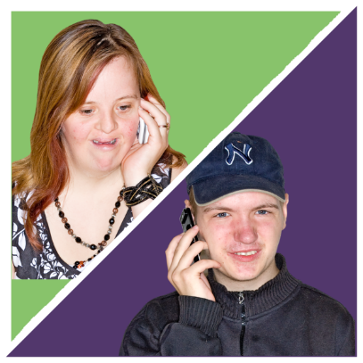- They are working with Shropshire Council to make 'happy boxes' for people who are at home because day services are not available.

- The group are supporting each other over WhatsApp calls.

- To get in touch, call 01743 364450 or email takingpart@takingpart.co.uk

- They have an easy read website: www.TakingPart.co.uk

Darlington Association on Disability

- They have set up closed Facebook groups to share fun daily activities, including cooking videos and exercise sessions, as well as easy read information and videos about the Coronavirus.

- For people who need it they have been delivering essentials like food, as well as fun things like sunflower seed kits, colouring, word games, books and jigsaws.

- They run a telephone helpline where people can call for support or get regular calls if they want them.

- They have run weekly Zoom meetings and shared fun videos and songs over WhatsApp.

Email keepingconnected@darlingtondisability.org or call 01325 489999

Brighton and Hove Speak Out

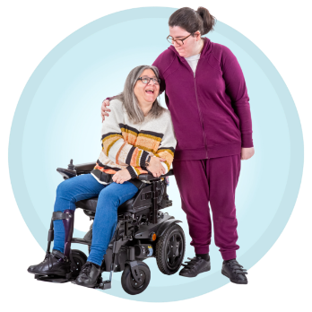

- They are running a daily helpline (7 days a week) offering welfare calls to people. The main issue that people report is feelings of isolation.
- They are supporting people online through Facebook chat, Zoom advocacy groups and drop-ins including film nights and art groups.
- They are running a new ‘Quiet’ Zoom group for people who need a smaller, quieter space to discuss issues.
- They have shared Easy Read information about the Coronavirus and how to keep safe, as well as creating a new Easy Read newsletter.
- They are now creating a video interview series called 'Speak with Danielle', which shows how different people are coping with being in lockdown.
Call their helpline on 01273421921, or find out more about how to join in at https://www.bhspeakout.org.uk/

Croydon People First

- They have shared quizzes, wordsearches and poems with as many people as possible through their newsletter.
Contact info@croydonpeoplefirst.org.uk to find out more.

NWTDT and Pathways Associates
- They are running different activities and events every day on Zoom, including a cinema club, bingo and dance classes.

- Every Monday at 9:45am you can join Vicki on Zoom for a news round up and chat; 2-pm-3pm you can join Danielle for a basic graphic facilitation skills session. On Thursdays 2-3pm you can join Danielle for coffee and chat.

- On Thursday 28th July they will be running the North West Family Forum over Zoom. This is a chance to relax and meet other families – bring your own drink!

- Until 18th September you can take part in a sponsored ‘virtual walk to Blackpool’, raising money to help people attend the annual Blackpool Self-Advocates Conference.

- Visit www.facebook.com/supportingourwellbeing for a list of the latest activities. Email events@pathwaysassociates.co.uk to get more information, or the link and password for Zoom events.

This is just some of the work that we have heard is being done by self-advocates groups. If you know of any more great work that we can mention – please be in contact with one of our LDE team members at:

anna.balding@ldengland.org.uk
or
gary.bourlet@ldengland.org.uk

