Socialising and getting back to normal
Gosh, I have found it great finally getting to go out instead of being stuck in doors all the time.

But I know some people who are not going out at all as they are frightened about getting ill and I completely understand this too.
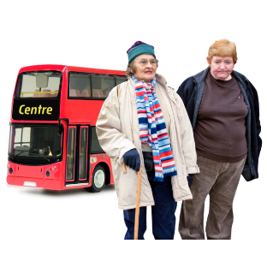 | Some people are still not feeling confident and others are a lot more comfortable.  Others feel safe doing some things, such as travelling locally, but feel more worried doing other activities like traveling further away.
 | I know a lot of people who are worried about using public toilets because they fear they might catch something – this makes travelling longer distances impossible.
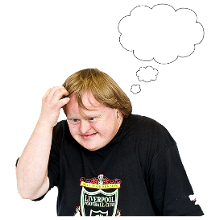 | I personally feel ok going out for walk and travelling very short distances on the train. I would also love to go cycling but I have not got a bike.  But I would feel worried going to a busy shopping centre or out for a meal with lots of people.
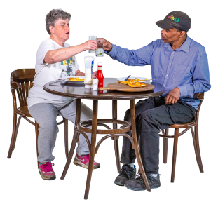 | I have gone to dinner with one friend from my social group and I sometimes go with my neighbour but more than this would worry me.  I have also been using the 50% off food scheme to go for meals alone. But I miss meeting my friends on a Friday afternoon in the café. They would talk about their artwork and have a chat about life in general.
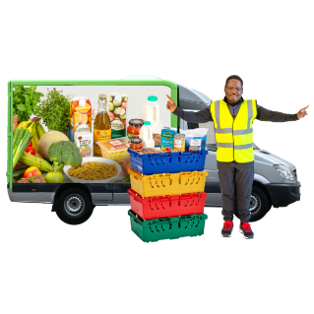 | I also have my shopping delivered from Iceland (no not the Country) but the supermarket.  Because I don’t feel completely safe in a supermarket and the masks are so uncomfortable for me.
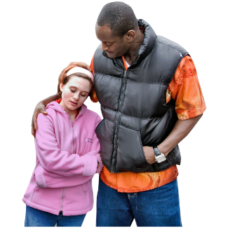 | The point I want to make is, everyone is different, and it is ok if you feel less confident than others going out and about or doing some things.
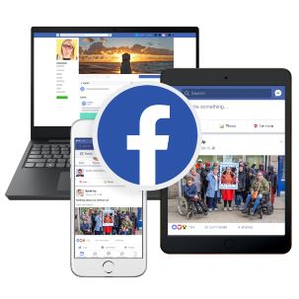 | I spend a lot of my day in the house on Facebook keeping in contact with friends on Facebook messenger because I feel safer. I don’t want to go out more than is necessary.  It also makes me feel better to stay connected with people online.
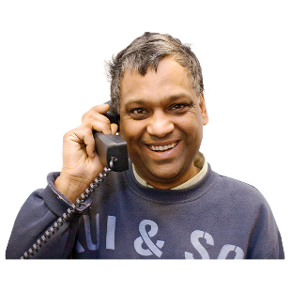 | It’s important to stay connected to people in some way whether that’s through telephone, zoom, Facebook messenger or whatever.  Speaking to loved ones, friends and work colleagues is important for your mental health.
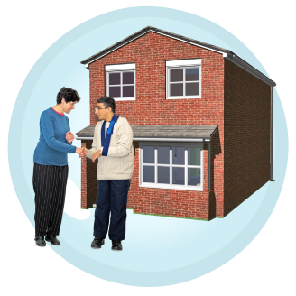 | I’m so glad I have contact with my neighbour, she helps with my cleaning and laundry and we have a chat. I also have all my work mates on zoom and any problem I have they are there.  But I know not everyone is lucky enough to have someone like this in their life.
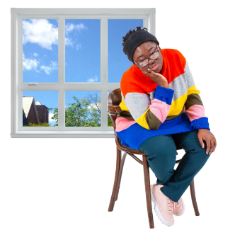 | I doubt I am alone when I say I wish this was all over. I would love life to get back to normal and to go back to work instead of working from home, go to conferences and meetings and meet people in general.
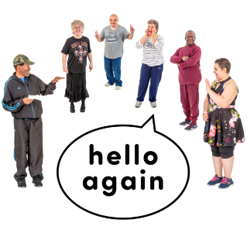 | These are difficult times for everyone but it’s important to go at your own pace.  Remember that in time – things will be normal again.

