Embargoed Press Release
Not before 00.01
Monday 16 November 2020
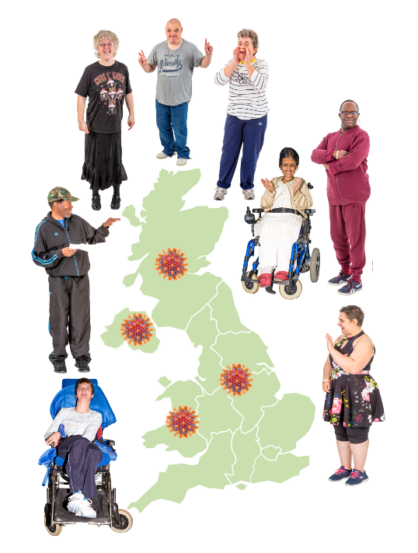

Coronavirus and people with learning disabilities:
a study of the lives of people with learning disabilities through the coronavirus pandemic

There is a new team of university researchers working in the UK.

Researchers ask people questions to find out new information.

 | The coronavirus (Covid-19) pandemic has meant a lot of changes for everybody.
The researchers want to ask adults with learning disabilities about these changes and coronavirus.

They will tell the people who can make things better for people with learning disabilities what they find out.

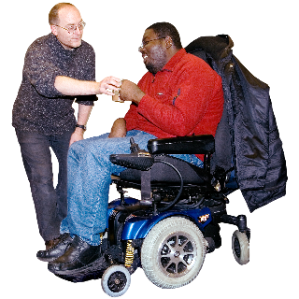 | Some adults with learning disabilities will need someone else to answer the questions on their behalf.  The researchers want to speak to family carers or paid support staff of these adults.
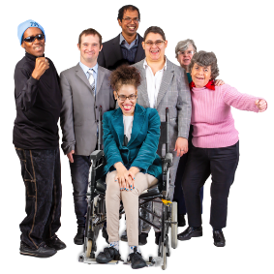 | Before the coronavirus pandemic people with learning disabilities were more likely to have worse health, worse support, and less money than people who don’t have learning disabilities.
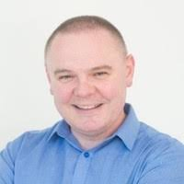  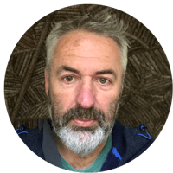 | Who is leading the team?  The researchers are being led by Professor Richard Hastings  and Professor Chris Hatton  Richard works at the University of Warwick  Chris works at Manchester Metropolitan University.
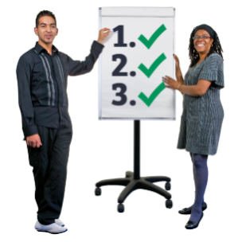 | What do they want to do?  The researchers want to talk to 1000 adults with a learning disability  They want to talk to 500 family carers or paid support staff of adults with a learning disability  They want to talk to these people three times over the next year.
 | UK Research and Innovation have paid for them to do this research.
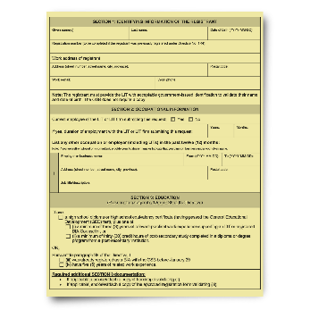 | Why do they need to do this work?  Professor Richard Hastings said there are other studies about Covid-19 but these are hard for people with a learning disability to take part in.  Their voices are not being heard by the people who make decisions about how to make things better for people.
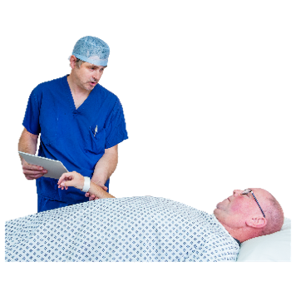 | Covid-19 can make people with learning disabilities very poorly.  So it is really important to talk to people with learning disabilities about their experiences.
 | What will happen after the work is finished?
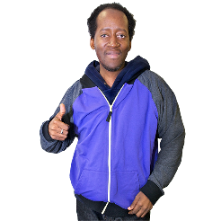 | The researchers will find things out.  The researchers will tell other people what they find.  They will tell people who can make things better for people with learning disabilities.
If you want to find out more about this study, you could look at this website:

www.covid19learningdisabilities.co.uk

NOTES

The project, COV0196 - The impact of Covid-19 and associated social restrictions on people with learning disabilities, their families and social care support workers, has been funded by the UKRI-DHSC COVID-19 Rapid Response Rolling Call.

Principal Investigators and Co-investigators: Prof Chris Hatton (Manchester Metropolitan University); Prof Richard Hastings (University of Warwick); Prof David Abbott (University of Bristol); Dr Stephen Beyer (Cardiff University); Dr Jill Bradshaw (University of Kent); Dr Nick Gore (University of Kent); Prof Pauline Heslop (University of Bristol); Prof Andrew Jahoda (University of Glasgow); Anna Marriott (National Development Team for Inclusion); Dr Katrina Scior (UCL); Dr Laurence Taggart (University of Ulster); Dr Stuart Todd (University of South Wales)

Third Sector participants: All Wales Forum of Parents and Carers of People with Learning Disabilities; Learning Disability Wales; Positive Futures; Mencap Northern Ireland; CAN N Ireland; Scottish Commission for Learning Disability; Promoting A More Inclusive Society (PAMIS); Learning Disability England; PMLD Link.

