Put your address

Put the date

Dear [put the Name of your MP]

This letter is about people with Learning Disabilities experiences of the pandemic

People with learning disabilities have been badly affected by coronavirus.

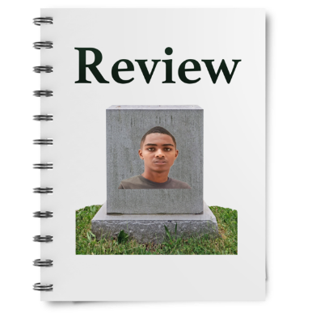 | Public Health England and the Bristol University learning from deaths have new reports.  They think people with learning disabilities are dying from covid-19 at 3.6 to 6 times the rate of general population.
These reports show the impact of a lack of;
- appropriate support,
- correct health care treatment
- and the critical lack of accessible information.

I believe people with learning disabilities and their families have been excluded and forgotten in debates, planning, and policy.

 | The Learning Disability and Autism Advisory Group for the Governments Social Care Taskforce published their report on what needs to be done to support people through the pandemic.
 | They make the following recommendations which I think are very important.
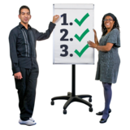 | The Top 5 plans from our report were important plans about the whole country for the government and others like NHS England  These actions are important because they are the what people with learning disabilities, family members and supporters said they need to happen now.
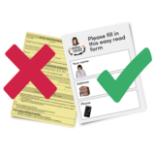 | - Make the rules and guidance accessible at the same time as they come out.  People with learning disabilities and autistic people must have the same information at the same time as everyone else.
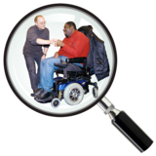 | - Make sure support services start up again or change how they work.  At the same time stop reviews or changes that are not needed by the people who get support.  These changes will help people and their families feel less worried and afraid – people said they need support they can trust and works for them.
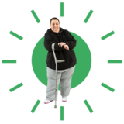 | - Make sure all support organisations have enough money and help to do their job during Coronavirus.  This includes them having enough PPE and tests for staff and people supported.  This must include all kinds of support and especially community support that is person centered.
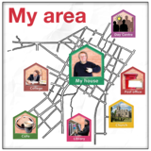 | - Help stop so many people being alone and feeling lonely by helping people with learning disabilities and autistic people know about the community groups near them.  Also the government should help community groups work out how they can include people with learning disabilities and autistic people.
 | - Councils, and Health services should find and support people who do not get social care support usually but who are finding it hard to cope during Coronavirus.
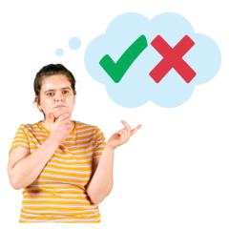 | I would like to ask for your support for these recommendations and to help make them happen  I would like you to help remind people that they need to think about people with learning disabilities with they are thinking about new policies.
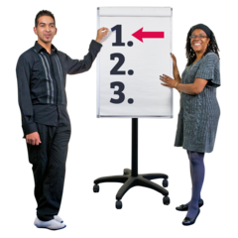 | We know lots of people have already died.  Making people act on the recommendations cannot wait.

I look forward to hearing back from you

Yours sincerely,
[Your name]

