What are self-advocacy groups doing at this time?
Some of the ways self-advocacy groups across the country are staying productive, connected and helping their members through covid-19

If your group is on this list and your activities have now changed, please let us know.

CHANGE
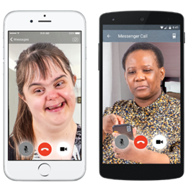 | - They are doing a weekly zoom call that gives people with learning disabilities and autism a chance to talk about what’s going on in the world, to share worries, get advice and just chat.  - This zoom call is being held every Wednesday at 12.30pm.  - They are sharing a zoom link weekly on their Twitter page.  - You can click on it if you want to join the call.
Social media:
Facebook - @changepeople
Twitter - @changepeople_
Website: www.changepeople.org
Brighton and Hove Speak out
- They are offering a support helpline for people with learning disabilities during the coronavirus outbreak.

- You can access this helpline for help dealing with a problem, for information or just for a chat.

- The number to call is: 01273 421921 between 9am and 5pm.

- They also have an information hub and chat group that you can access through their Facebook page.

Social media:
Facebook - @bhspeakout
Twitter - @bhspeakout
Website: www.bhspeakout.org.uk
People First Dorset
- They have produced an activity board which includes different activities to do each day to keep people busy and entertained while staying in-doors.

- They have also produced a coping calendar that has different daily things you can do to support your mental health and wellbeing.

- Please click here to see these calendars: Dorset People First Coping calendar and Activity Board

- They now have a NEW accessible 'Walk and Talk Club'. People can meet new friends, do exercise in a relaxed environment and explore different areas in their local town.

- They now do weekly zoom calls so people can catch up with friends.

- They also do a weekly ‘Connect’ newsletter with useful information to help people understand the government updates and the impact of coronavirus on people with a learning disability. It also has lots of ideas of things to do, like relaxation exercises, puzzles, poems and recipes. See all the issues so far here: https://www.peoplefirstdorset.org.uk/resources

- If you are interested in this ring 01305 257600 or email laurad@peoplefirstdorset.org.uk
Social media
Facebook - @Peoplefirstdor
Twitter - @Peoplefirstdor
Website: www.peoplefirstdorset.org.uk
Speak up
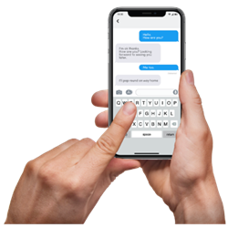 | - They have a WhatsApp group and have 25 people chatting on this every day.  - A zoom call at 11am every day - they have up to 20 people joining this call. They check in with each other to make sure they are all ok and chat about the work they can all do.  - A Quiz that they do every week.  - They are currently putting lots of resources and training material on their website to help people. These resources have been coproduced by their self-advocates with learning disabilities, autism or both.
Social media:
Twitter - SpeakupSA
Website: www.speakup.org.uk
Skills for people
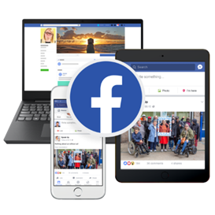 | - Their self-advocates have set up a Facebook page called Stay Connected and they are having daily video calls to plan what is being put on this page.  - This includes jokes, important news in easy read and fun competitions to do at home.  - Their members also post informative videos such as what it’s like to get tested for covid-19.  - They are also running a get well for winter campaign which is more important than ever given the risks around Covid19. Go to their website and social media for more details (see below).
Social media:
Facebook - @skillsforpeople
Twitter - @skillsforpeople
Website: www.skillsforpeople.org.uk
People in Action
- Have invited all their members (and whoever else would like to join) to their daily Zoom chats and activities:
- 11am - chats and games
- 2pm - Stay Active - inclusive exercise session
- 4pm - Member chat
- Contact them for the passwords to join!

- They post weekly arts and crafts videos on their Facebook too.

- Staff are also posting out Boredom Buster activity packs and calling members on the phone.

Social media:
Facebook - @PeopleinActionPIA
Twitter -@PeopleinActionPIA
Website: www.people-in-action.com
People first Merseyside

- Have a new updated website.

- Have transferred their group meetings with their members to zoom so that they can still work and socialise.

- Recently had an online disco for all their members and staff.

- Are sharing daily updates on covid-19 on their Facebook page.

- Also keeping members up to date through Facebook with what's happening, and activities people can get involved in.

Social media:
Facebook – @PeopleFirstMerseyside
Twitter – @PFMerseyside
Website: www.peoplefirstmerseyside.co.uk
Cornwall People First
- They have been producing Easy Read guidance since March on Covid 19 - all available via their Facebook page (see below).

- They have a new project called 'Back on Track' which is aimed at supporting people by phone, text, video calls and face to face meetings.
- Their Covid compliant face to face meetings (one to one and groups) have been really popular, especially the Walk and Talk groups.

- They are also creating resource packs which we will support people to use to explore health and wellbeing, meaningful occupation and setting and reaching goals.

- We are also offering specialist support for people who have been particularly affected by the lockdown rules and are finding it difficult to adjust.

Social media:
Facebook – @cornwallpeoplefirstofficial
Twitter – @CPF_Info
Website: www.cornwallpeoplefirst.com
People First Forum
- Have a new internet based phoneline which goes to staff mobiles 01202 051014

- Live videos on Facebook which tell their followers how they are coping, gives them up to date information on the coronavirus as well as lots of useful links on exercise, mental health, food deliveries, where to get other support etc.

- Pre-recorded videos every Saturday on their social media for entertainment.

- They have put a list together of their most vulnerable members who do not have the internet and call them weekly.

- They have also made a ‘my diary of the coronavirus 2020’ so people can record their experiences and are sending out to their 800+ members. You can find this on their website (see below).

- They are also sending out to their members a Coronavirus 2020 survival pack which contains lots of content to keep them informed and entertained right now.

- They are also setting up Zoom meeting with their members, so people can speak up and keep in touch with each other.

Social media:
Facebook – @PeopleFirstForum
Twitter – @People1stForum
Website: www.peoplefirstforum.co.uk
My Life My Choice
- They are running online events and activities on their Facebook. Activities have included short films about traveling independently, easy cooking recipes, easy crafts, accessible exercises, and regular online Stingray Nightclub events.

- They are sending mailouts every two weeks with the latest government advice, social activities and fitness activities that people can do at home.

- If you would like to receive a mailout or have any questions, please contact Lisa by emailing her at lisa@mylifemychoice.org.uk

- They are running a Coronavirus helpline Monday to Friday, from 10am to 4pm. Please call 01865 204214 if you would like to receive support.

- Their phone buddy project links you up with a Phone Buddy to keep you company during the crisis. If you want to find out more or make a referral, please contact Yazz by calling 01865 204214 or emailing her at yazz@mylifemychoice.org.uk

Social media:
Facebook – @1MLMC
Twitter – @mylifemychoice1
Website: www.mylifemychoice.org.uk
Lewisham Speaking Up
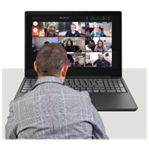 | - They have Speaking Up meetings every week online - they are on Tuesdays at 4:00 pm.  - They use Zoom video to meet. You need a code to join the meeting.  - If you would like to join email martin.stitchman@lsup.org.uk and they will send you a code. Or send them a message on Twitter, Facebook or Instagram.  - As people are using social media a lot at the moment, they have put together a video which they have shared on Facebook called ‘Top Tips for staying safe online’.
Social media:
Facebook – @LewishamSpeakingUp
Twitter – @LewSpeakUp
Website: www.lsup.org.uk
People First Tameside
- They have been delivering food parcels to their most vulnerable members and their families.

- They have a whole online activity programme full of things going on including; a drawing group and karaoke night.

- To see their most recent activity programme, go to their website or Facebook (see below).
Social media:
Facebook – @peoplefirsttameside
Twitter – @Pftameside
Website: www.peoplefirsttameside.org
Your Voice Counts
- They are continuing to support the most vulnerable people in the community and are doing over the telephone or video calling as much as possible.

- They are also contacting those who come along to their drop-ins, group activities or self-advocacy groups, and making sure they have the support they need over the coming weeks.

 | - They are helping people to make plans, including how to get food, medication and how to use technology to stay connected.
Social media:
Facebook – @YourVoiceCountsCommunity
Twitter – @YVC_Advocacy
Website: www.yvc.org.uk
Pathways associates/NWTDT
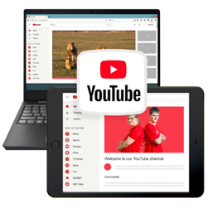 | - They are sharing daily video updates (Monday to Friday) to make sure that people have accessible, accurate and up to date information about COVID 19.  - Their most recent video talked about wearing face coverings.  - They have a big range of online activities going on such as singalongs, yoga, cinema club and bingo.  - They post videos whenever there is changes in Covid guidance and summarise the changes in an easily accessible.
Social media:
Facebook – @nwtdt
Twitter – @nwtdt
Website: www.pathwaysassociates.co.uk
Our voice group
- They have restarted their filmmaking club for adults with learning disabilities which they are running online. These are weekly virtual filmmaking clubs.

- Members are currently planning some lockdown experience videos.

- For more info see their twitter: @ourvoice-filmmakingclub

- They are frequently updating their Facebook page with online events going on, easy read info and updates.
Social media:
Facebook – @OurVoiceGroup
Website: www.ourvoice.org.uk
Sunderland People First
- They now have a ‘Keeping People Connected’ phone Service which is free and available now for people with learning disability and / or autism who need support.

- This service is helping make sure people understand the coronavirus, helping them to problem solve and stay connected as well as access other services.

- To contact this service call: 07858 226 18

- They have a live stream schedule which shows all their up and coming live streams. To see this, go to their Facebook (see below).

- They also post regularly to their social media with updates on guidance around the virus.

Social media:
Facebook - @SunderlandPeopleFirst
Twitter - @SunPeopleFirst
Website: www.sunderlandpeoplefirst.com
Talkback UK
- They have started Talkback TV, a Youtube channel for people with learning disabilities and/or autism. The videos feature dance, yoga, mindfulness and calming art.

- Follow this link to go to their YouTube Channel: https://www.youtube.com/channel/UCXxPLCj449J4QeO_R6ozVjQ/videos

- They have been running regular Zumba classes and drama groups online, as well as events like a Danceathon.
- The Think Feel Belong group are offering phone calls every week to people with learning disabilities who live in Reading. They can provide relaxation techniques, mindfulness, breathing exercises, a talking group, and the chance to discuss how you are feeling. To join in, email sue.pigott@talkback-uk.com.

- The Come and Meet Each Other (Reading CAMEO) an autism support group has been speaking over the phone or via Zoom. If you live in Reading you can join in the twice weekly calls by emailing: sue.pigott@talkback-uk.com.

Social media:
Facebook – @TalkbackNclude
Twitter – @Talkback_UK
Website: www.talkback-uk.com
Taking Part
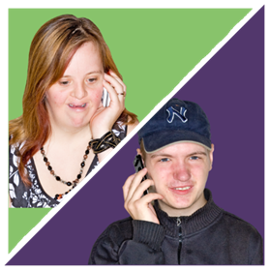 | - They are working with Shropshire Council to make 'happy boxes' for people who are at home because day services are not available.  - The group are supporting each other over WhatsApp calls.  - To get in touch, call 01743 364450 or email takingpart@takingpart.co.uk
Social media:
Facebook –
Twitter –
Website: www.TakingPart.co.uk
Darlington Association on Disability
- They have set up closed Facebook groups to share fun daily activities, including cooking videos and exercise sessions, as well as easy read information and videos about the Coronavirus.

- For people who need it they have been delivering essentials like food, as well as fun things like sunflower seed kits, colouring, word games, books and jigsaws.

- They run a telephone helpline where people can call for support or get regular calls if they want them.

- They have run weekly Zoom meetings and shared fun videos and songs over WhatsApp.

- Email keepingconnected@darlingtondisability.org or call 01325 489999

Social media:
Facebook – @DarlingotnAssociationonDisability
Website: www.darlingtondisability.org
Brighton and Hove Speak Out
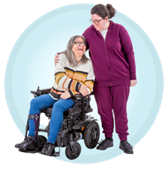 | - They are running a daily helpline (7 days a week) offering welfare calls to people. The main issue that people report is feelings of isolation.  - They are supporting people online through Facebook chat, Zoom advocacy groups and drop-ins including film nights and art groups.  - They are running a new ‘Quiet’ Zoom group for people who need a smaller, quieter space to discuss issues.  - They have shared Easy Read information about the Coronavirus and how to keep safe, as well as creating a new Easy Read newsletter.  - They are now creating a video interview series called 'Speak with Danielle', which shows how different people are coping with being in lockdown.  - Call their helpline on 01273421921.
Social media:
Facebook – @bhspeakout
Twitter – @bhspeakout
Website: www.bhspeakout.org.uk
Croydon People First
- They have shared quizzes, wordsearches and poems with as many people as possible through their newsletter.

- Contact info@croydonpeoplefirst.org.uk to find out more.
Social media:
Facebook – @croydonpeoplefirst
Website: www.croydonpeoplefirst.org.uk
Keyring
- They are holding monthly self-advocacy online meetings, as well as weekly phone or video calls with self-advocates.

- They are running a weekly quiz with general knowledge and music questions where each week someone different is the host.

- They are making regular activity packs around issues they would have talked about in meetings - for example, keeping safe, mental health, human rights, hate crime and staying healthy.

- They have been sharing stories and the experiences of self-advocates during COVID.

- If you would like to get involved in any of this email Karen.murray@keyring.org or phone 07833309693

Social media:
Facebook – @keyringlivingsupport
Twitter – @KeyRingCJS
Website: www.keyring.org/keyring-yorkshire-and-humber/self-advocacy-service
Together all are able
- They are holding a Covid safe coffee event on zoom every other Friday afternoon at 12pm – many of their members join and socialise.

- For more information on these events and updates on what they are doing follow them on Facebook.
Social media:
Facebook - @TogetherAllAreAble
Twitter – @able_together
Active prospects – Surrey people’s group
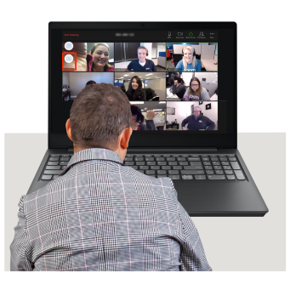 | - They are doing online group meetings on zoom on the first Wednesday of every month.  - Anyone is welcome to join. The zoom ID for these meetings is 833 5711 7803 if you would like to.  - The dates for meetings over the next few months are:  October 7th  November 4th  December 3rd  January 6th  February 3rd  March 3rd
Social media:
Facebook – @ActiveProspectsUK
Twitter – @Active_Prospect
Website: www.activeprospects.org.uk/
This is just some of the work that we have heard is being done by self-advocates groups. If you know of any more great work that we can mention – please be in contact with one of our LDE team members:

anna.balding@ldengland.org.uk
or
gary.bourlet@ldengland.org.uk

