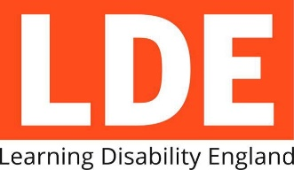
Equal Treatment:
Challenging racism and health inequalities through strengthening self-advocacy and peer support
Application Form

Please email the complete application to info@LDEngland.org.uk
The application deadline is 1st November 2021 at 5pm

Which work stream are you applying for?  (please delete as appropriate) | Strand 1: Strengthening inclusive self-advocacy  Strand 2: Strengthening family led or parent peer support  Strand 3: Strengthening local community responses on tackling health inequalities and unfair treatment
Organisation Name

Key contact within your organisation:
Name
Email
Phone number
1. Please tell us about your organisation and who will be involved in doing this work

2. Please tell us the skills and experience you have of work like this

3. How you would do this work, including;
- Initial plans for coproducing the training
- How you would work with the other partners in the project
- How you would work with the 15 self-advocacy groups
- How you would fit everything in before 31st May 2022

4. Please tell us what support you might need from Learning Disability England or the other partners

5. References: Please provide the contact details of someone we could ask about work you have previously done

