What type of money do I get paid? | How much money do I get paid? | How often do I get this?
 | £
 | £
 | £
 | £
TOTAL (A) | £
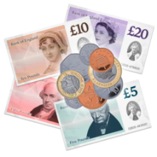
This is my budget__________________________
You can ask someone you trust to help you fill it in.

This section is about the money you get paid from wages, benefits or your pensions.

You can use this link to find out more about money.
https://www.fca.org.uk/publication/documents/everyday-banking-easy-read-guide.pdf

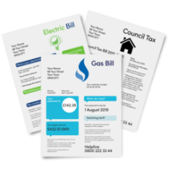
This section is about what you need to spend your money on.

The maths
You need to take
(B)£_____ away from
(A)£_____ and you will be left with £______
What do I need to pay? | How much will it cost? | Can I get any help with this?
Rent | £
Council tax | £
Water | £
Gas | £
Electric | £
Phone | £
TV licence | £
Food | £
Insurance | £
Travel | £
Leisure | £
Total (B) | £

