Ethnicity and Difference in Health and Care

This information sheet is about research you could take part in

Page 3 is a list of useful words and what they mean
Page 4 is about why we would like to make care better for people
Page 5 is about how you can take part
Page 6, 7 and 8 is about what will happen if you take part
Page 9 and 10 is about what will happen to the information you give
Page 11 is about making the decision to take part
Page 12 and 13 is about who you can talk to

Before you read this leaflet here is a list of useful words and what they mean
When it says ‘we’ and ‘us’ this means a group of people that are working together from:
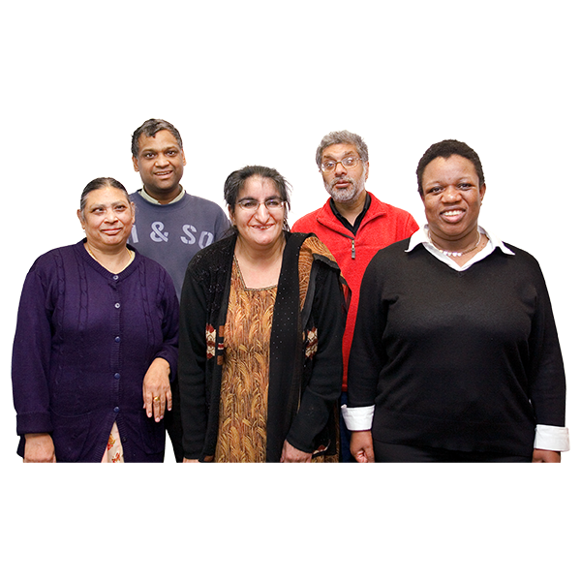 | A charity called Learning Disability England and another charity called Race Equality Foundation.  These charities are working with the University of Central Lancashire and Manchester Metropolitan University.  When it says ‘minority ethnic groups’ this includes people who are black, Asian, people with a mixed ethnic background, and people from Gypsy, Roma and Irish Traveller groups.  When it says ‘health care services’ this could be:  - GP surgery  - hospital  - dentist  - And other places you go for appointments to do with your health or when you are feeling unwell.

How can we make care better for people from minority ethnic groups with a learning disability?
People from minority ethnic groups have more problems with their health.

We know this from a report called LeDeR which tries to understand why people with a learning disability have sadly died.
The report found that people from minority ethnic backgrounds are more likely to die younger than people who are White British. We want to know why this is happening and make care better.

We want to know why it is hard for people from minority ethnic groups with a learning disability to use health care services.

One reason is they might speak different languages and find it harder to get information.

Racism is another reason people from minority ethnic groups might not be treated equally.

We want to ask people with a learning disability from minority ethnic groups what they think. You have been asked to take part because with your help we can learn more about this.

Would you like to help us and take part?
Please look at the next page for information on how you can take part.
Information on how you can take part
Anyone aged 18 years old and older with a learning disability from a minority ethnic group can take part.

Young people between the ages of 14 and 17 can also take part. But they need the permission of their parent or guardian to take part.

You will be part of a group. You will talk and listen to other people in the group.

There will be 4 or 5 other people with a learning disability. You can have someone with you in the group to help you take part, if you want to.

There are two ways you can choose to take part
Online on a Zoom video call
OR
In person in a room with other people

You will be offered a £20 love to shop voucher for each hour of your time. We will give you support to take part. We will pay any travel costs for you. If you have a carer with you we will pay for their travel costs as well.

Please look at pages 6, 7 and 8 for information on what will happen if you take part.
What will happen if you take part

The groups will happen in October and November 2022.
In the group we will talk to you about health and care services for people with a learning disability from a minority ethnic background.

People who work at Learning Disability England, the Race Equality Foundation and the University of Central Lancashire will organise and lead the meetings.

We will record the group meetings. This is so we can listen back to meeting and hear what everybody said.

We will type up notes of what happened and what people said in the group. This is so we do not forget all the important things you say.

We will ask you if it is okay for us to photograph any notes you might make during the meeting.

There will be rules in the group to make sure everyone feels safe, happy and respected.

In the group we will agree the rules and how we want to work together

We cannot totally promise that everyone will follow all the rules.

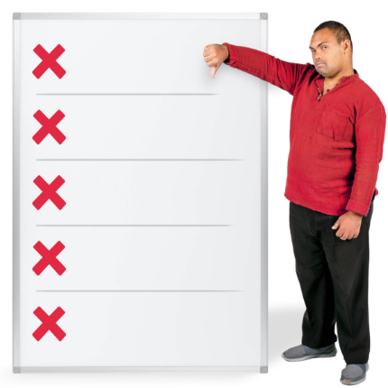
If we know someone has not followed the rules then we will let you know.

We will remind everyone about the rules at the start of all the meetings.

We will try our best to make sure you feel safe, happy and listened to in the group.

We will not tell other people that you took part in the research.

We will not share your personal information like your name or address with anyone who is not involved in this research project.

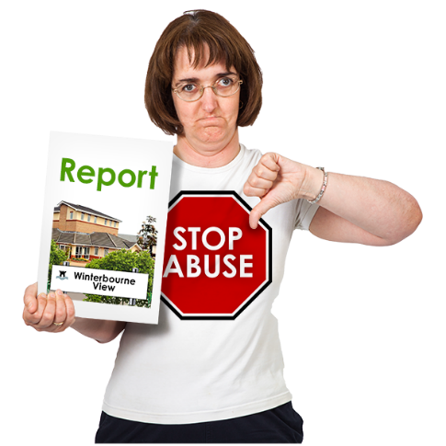
The only time we will tell someone what you said is if you talk about abuse by someone who is meant to care for you.

This is to make sure you are safe.

Any abuse or bad practice by services will be reported to the people who inspect those services.

Please read the next page about what will happen to the information you give.

What will happen to the information you give
Before the meetings, we will ask you to tell us your gender, age, religion and ethnicity.

We ask for this information so we can make sure the group is including everyone that it should.

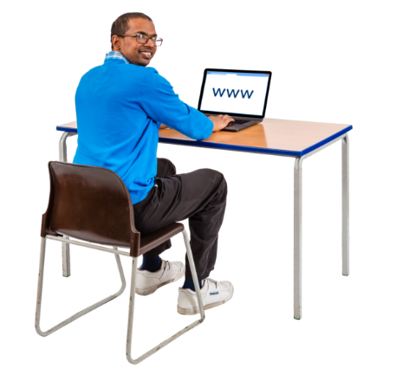
This information will be collected by a form online. You do not have to give this information if you do not want to.

We can help you to complete this form. The information you tell us will only be seen by the research team.

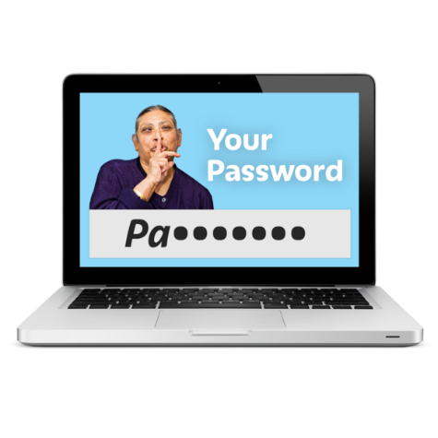
What we talk about in the meetings and any notes will be put on to a computer. This computer can only be opened with a password. This is to keep your information safe. Only the researchers know the password and they will not share it with anyone.

After the workshops we will write an easy-read report that is a summary of what we find out. We will send everyone that takes part a copy of the report. So, you will know the outcomes.

Your name and contact details will not be put in the report. No one who reads the report will know you took part.

The report will be shared with health care staff. Anyone will be allowed to read the report.

This is so as many people as possible can learn from what you have said and make care better.

We may want to write about what we find out in a research journal. A research journal is a type of book.

We may also talk about what we find out at other meetings and do presentations.

This is to make people who make decisions about health care services can make care better.

Please look at pages 11 and 12 for information on deciding if you want to take part and who you can talk to.

Information on deciding if you want to take part
If you take part:
you will be listened to
you will help to make services better
you will meet new people

There are things that might make it hard to take part because:
you will be asked to tell us what you think
you might take part on a video call
you could be in a meeting for up to 2 hours. But there will be time for breaks.
you will only be able to attend 1 or 2 meetings, then the project will finish.
It is your decision if you want to take part.

If you say NO I do not want to take part that is OK.
You do not have to take part. No one will mind. You will not be treated any differently.
If you say YES I do want to take part that is OK.
You can change your mind later. You can leave at any time. We will understand and support your decision.
If you leave we will still use the recordings and notes from your meetings in our research. Your name and your contact details will be deleted.

Please read the next page for information who you can talk to.
Who you can talk to for more information

If you would like to take part or you have any questions please talk to Katie who is a research assistant on this project. Katie’s name, telephone number and address are below.

Name: Katie Umpleby
Address: School of Medicine, University of Central Lancashire, Preston PR1 2HE
Telephone: 01772 893919
Email: KUmpleby@uclan.ac.uk

You can also contact Professor Umesh Chauhan who is leading this research project.
Name: Professor Umesh Chauhan
Address: School of Medicine, University of Central Lancashire, Preston PR1 2HE
Telephone: 01772 893771
Email: UChauhan@uclan.ac.uk

The University of Central Lancashire also has information on their website about what is involved when you are a research participant. Please click on this link: www.uclan.ac.uk/legal/privacy-notices/research-participants. We can read through this with you if you are finding this difficult to understand.

Please read the next page for information who you can talk to if you are unhappy with the research.

Who to contact if you are unhappy or have a problem with the research?
If you are unhappy or if there is a problem please let us know.

You can contact the same people as in the pictures above – that is Katie Umpleby or Professor Umesh Chauhan at the University of Central Lancashire.

If you are still unhappy or you need to complain about something then please contact the Ethics, Integrity and Governance Unit:
Tel: 01772895583
Email: OfficerForEthics@uclan.ac.uk

If you have a complaint about how we used your personal information then please contact the Information Commissioner's Office by calling 0303 123 1113.

Thank you for taking the time to read this information sheet.

