An opportunity to take part in a research project called ethnicity and difference in health and care
Focus group meeting online

Tuesday 1st November 2022

10:00AM to 12:30PM
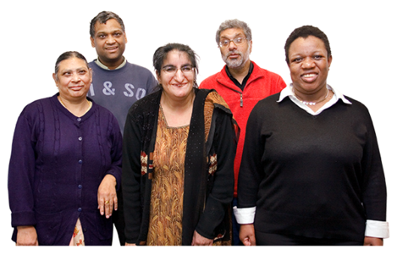 | This research project is about how we can make health care better for people from minority ethnic groups with a learning disability.
We want to talk to anyone aged 18 years old and older with a learning disability from a minority ethnic group.

Carers can also take part.
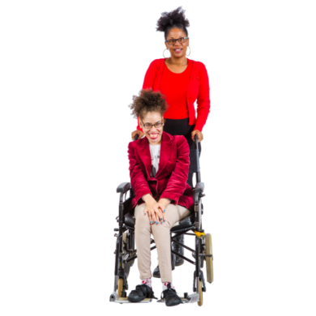 | Young people between the ages of 14 and 17 can also take part with the permission of their parent or guardian.
Please read the information sheet for more information about what is involved.

If you would like to take part, please contact Katie Umpleby Mon – Fri 9am until 5pm on 01772 893919 or email on KUmpleby@uclan.ac.uk

