UNRESTRICTED

Historians
Wolfson Project

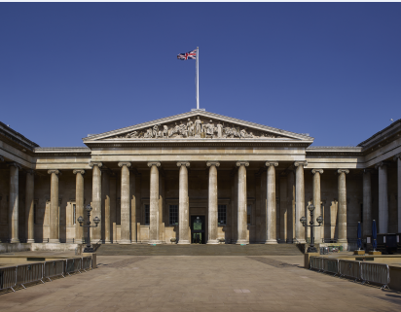

Hello, my name is Jess and I work at The British Museum on the Wolfson Project. My job role is to organise relaxed events for autistic and learning disabled adults and families when the museum is closed to other visitors, as well as supported volunteering. The work is funded by The Lord Leonard and Lady Estelle Wolfson Foundation.

The British Museum is in London. There are eight million objects in the collection. The museum still collects objects today.

As part of the relaxed event programming for adults we would like to organise an evening of talks presented by autistic and learning disabled historians.

What we mean by historian?
- Researcher (professionally or as a hobby)
- Knowledgeable
- Passionate

I would like to hear from historians who have researched an area of the British Museums collection and would be interested in sharing their knowledge to an audience at the museum. The British Museum displays objects from all over the world from:

- Africa, Oceania and the Americas
- Asia
- Britain, Europe and prehistory which includes Paleolithic archaeology, Neolithic, Bronze Age, Iron Age, Medieval, clocks and watches and renaissance ceramics
- Ancient Egypt and Sudan
- Ancient Greece and Rome
- Middle east
- Money (coins and paper) and Medals
- Prints and drawings

You can learn more about the British Museum collection by searching the collection at https://www.britishmuseum.org/collection

There would be a £250 payment for delivering the talk.

If you are interested please email access@britishmuseum.org and we can organise a Teams call to have a chat to find out more about your research and I can share more about the Wolfson Project.

britishmuseum.org

