Dear GP Surgery
 | My name is  ___________________________  I have a learning disability
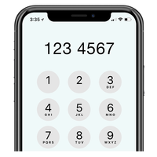 | My phone number is:
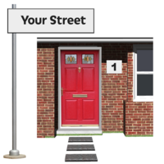 | My address is:
 | I would like to check:
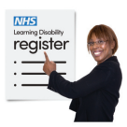 | - If I am on your learning disability register.
 | - If I need an Annual Health Check.
 | I need to talk to you about:
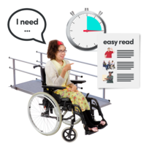 | What I need to make sure I can use your service when I visit  (Reasonable adjustments).
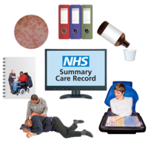 | My needs being shared on my Summary Care Record.
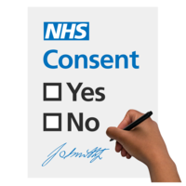 | How I might give consent for you to talk about my medical care.
 | Thank you.

