Proxy form

Please fill in the form below if you want to give someone else permission to vote on your behalf.

The person you chose does not have to be a member of Learning Disability England

 | Your name
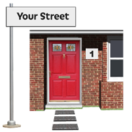 | Your address
 | Are you an individual member?
 | Are you the rep for an organisation or group?
Who do you want to vote for you?

Give their name and address

 | Do you give them permission to vote for you at the members general meeting on 19th May 2022.
 | Please sign here to confirm that you are a member and you are giving a proxy the right to vote for you
Date

You must e mail or post this to arrive at Learning Disability England by 5pm on 23rd February 2023 at the latest

 | E mail to info@LDEngland.org.uk
Post to
Learning Disability England
c/o 134 Edmund Street
Birmingham
B3 2ES

