Why we have our pronouns on our emails

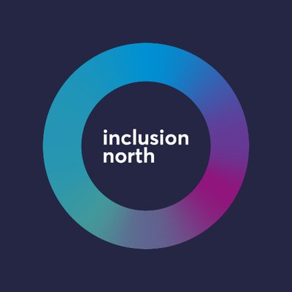 | We want to start by thanking Inclusion North for letting us share this easy-read information that they have put together.
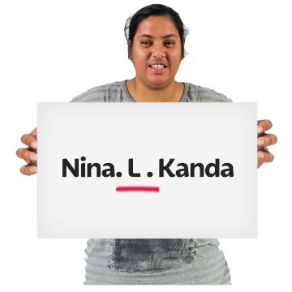 | Pronouns are the short words we use when we talk about someone instead of using their full name all the time.
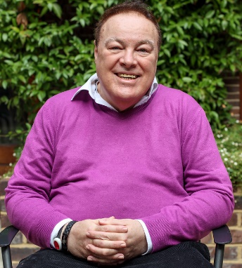  Gary | For example, Gary is a Membership and Engagement Lead. He works part-time. His usual days at work are Tuesday to Thursday.
He/him | In this example, he and his are Gary’s pronouns.
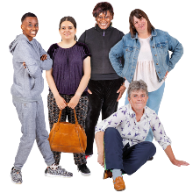  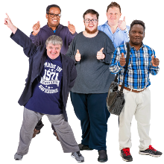 | The pronouns we use are often connected to our gender.  Gender means whether - or how much - we feel we are a man, a woman, a non-binary person, or another gender.
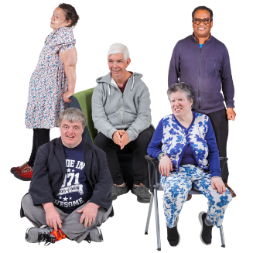 | Some people are both a man and a woman and some people have no gender.
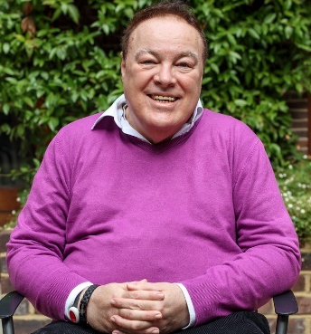  He/him | People who are men might use the pronouns he and him.
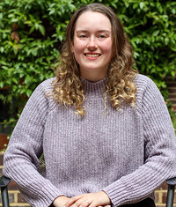  She/her | People who are women might use the pronouns she, her and hers.
 | Other people might use the pronouns they and them.
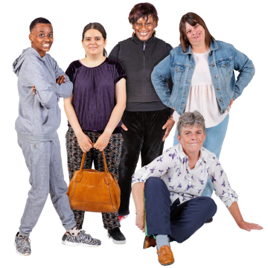 | This includes some non-binary people, some people who are a man and a woman, and some people who don't have a gender.
 | We have our pronouns on our emails so people know which pronouns to use.
 | This shows people that we are aware of different genders and that we accept people for who they are and that we respect them.
 | At Learning Disability England we work hard to make sure that everyone is treated with respect.

