Easy read about a taking part in a conversation about how to make support for adults in England better
This document is about the research, and your rights as a participant.
Thank you
Thank you for thinking about taking part in this project.

We want to hear your views about care and support.

Who are we?
National Voices and Ipsos are helping with this project.

We listen to people and help them share their views.
What is this project about?
The government has asked a new team of people to look at how to make support for adults better and fairer for everyone in England. The team is called The Casey Commission.

The Commission wants to know what works well and what could be better.
What is adult social care?
Adult social care helps people stay safe, well and independent.

Support may include washing, dressing, cooking, getting around and joining community activities.
Who can take part?
- People who receive care.
- People who care for someone else.
- People who live in communities like this one and who often do not have their views heard.

What will happen if I take part?
You can join a one-to-one conversation or a small group discussion.

You can take breaks and stop at any time.
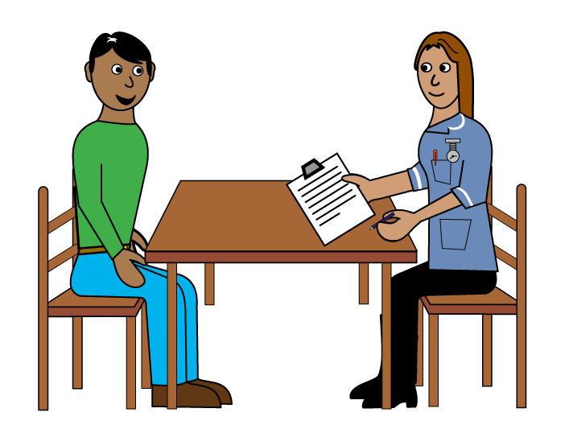 | What will we talk about?  We will ask about your life, your community and your experiences of care.  We will ask “The Big Question” about who should support people and how.
Do I have to answer every question?
No. You only answer questions you want to answer.

You can leave at any time.
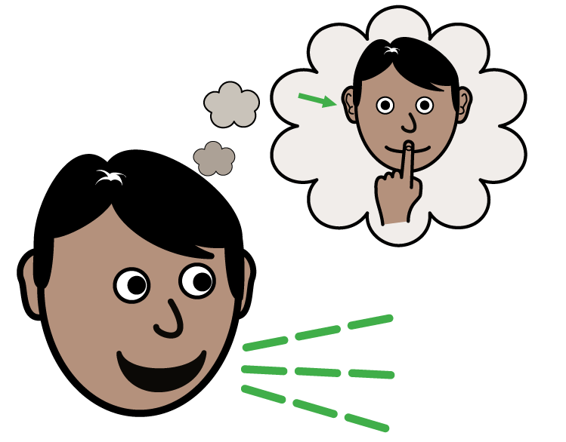 | Will my information be private?  Yes. Your information will be kept confidential.  Your name will not appear in reports.
 | Will the discussion be recorded?  If you give us permission, the discussion will be audio recorded to help with the research.
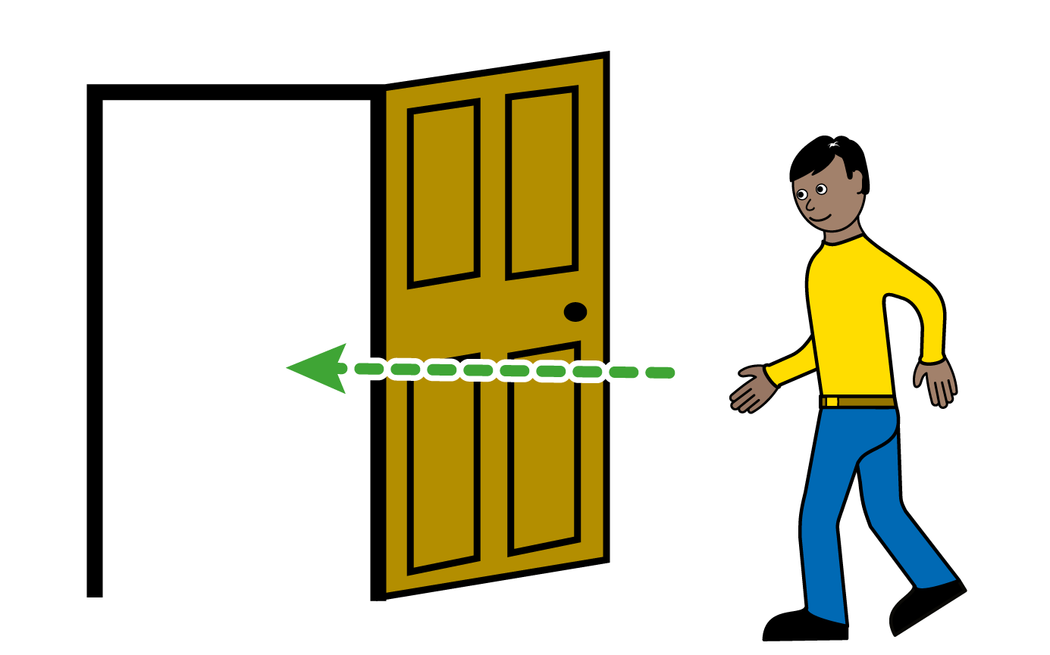 | Can I change my mind?  Yes. You can withdraw before or after the discussion.
 | Benefits of taking part  You can help improve adult social care.  You will receive a £50 voucher as a thank you.
What information will you collect?
We will ask about your first name, location and experiences.
You can choose how much information to share.
How will my information be used?
Your answers will be combined with other people’s answers.

Your name will not be published.

Your rights
You can ask to see your information, correct mistakes and make complaints.

 | Contact details  Ipsos: compliance@ipsos.com  DHSC: data_protection@dhsc.gov.uk
 | Thank you  Please ask if anything is unclear. We are happy to help.

